1. Write a C program to simulate a Deterministic Finite Automata (DFA) for the given language representing strings that start with a and end with a

#include<stdio.h>

#include<string.h>

int main()

{

char a[100];

printf("enter the string:");

scanf("%s",&a);

if(a[0]=='a'&&a[strlen(a)-1]=='a')

printf("accepted");

else

printf("not accepted");

return 0;

}

Output:

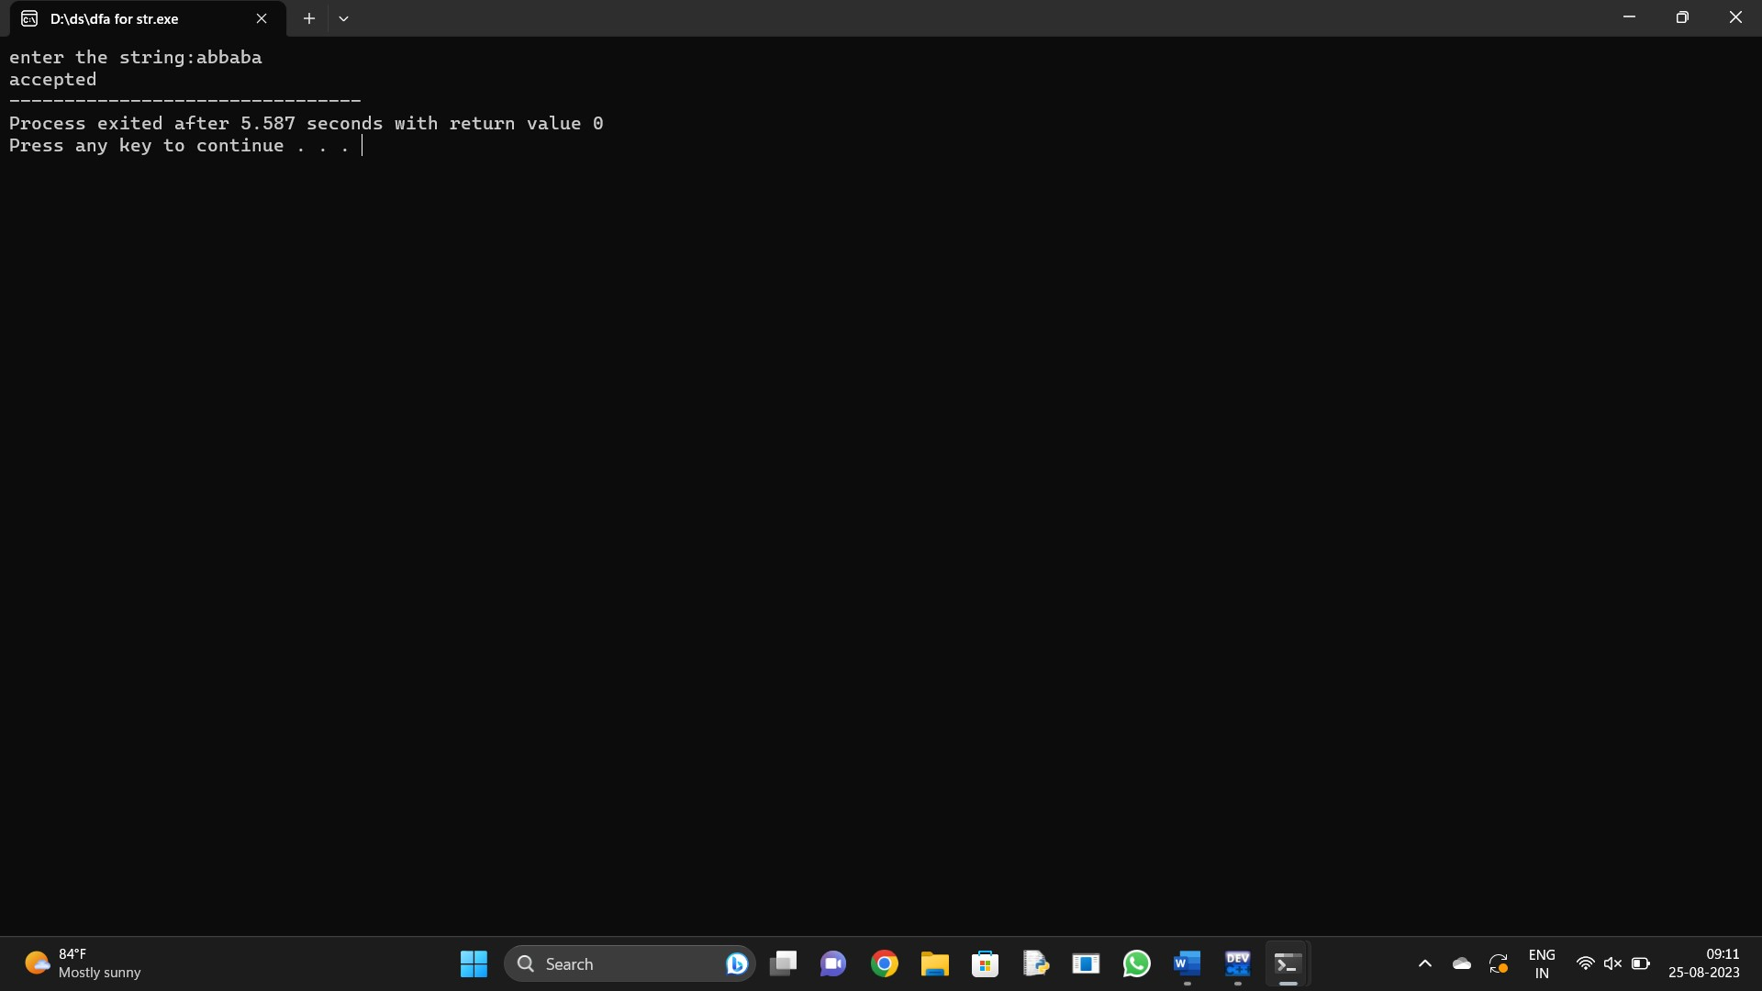

2.Write a C program to simulate a Deterministic Finite Automata (DFA) for the given language representing strings that start with 0 and end with 1

#include<stdio.h>

#include<string.h>

int main()

{

char a[100];

printf("enter the string:");

scanf("%s",&a);

if(a[0]=='0'&&a[strlen(a)-1]=='1')

printf("accepted");

else

printf("not accepted");

return 0;

}

Output:

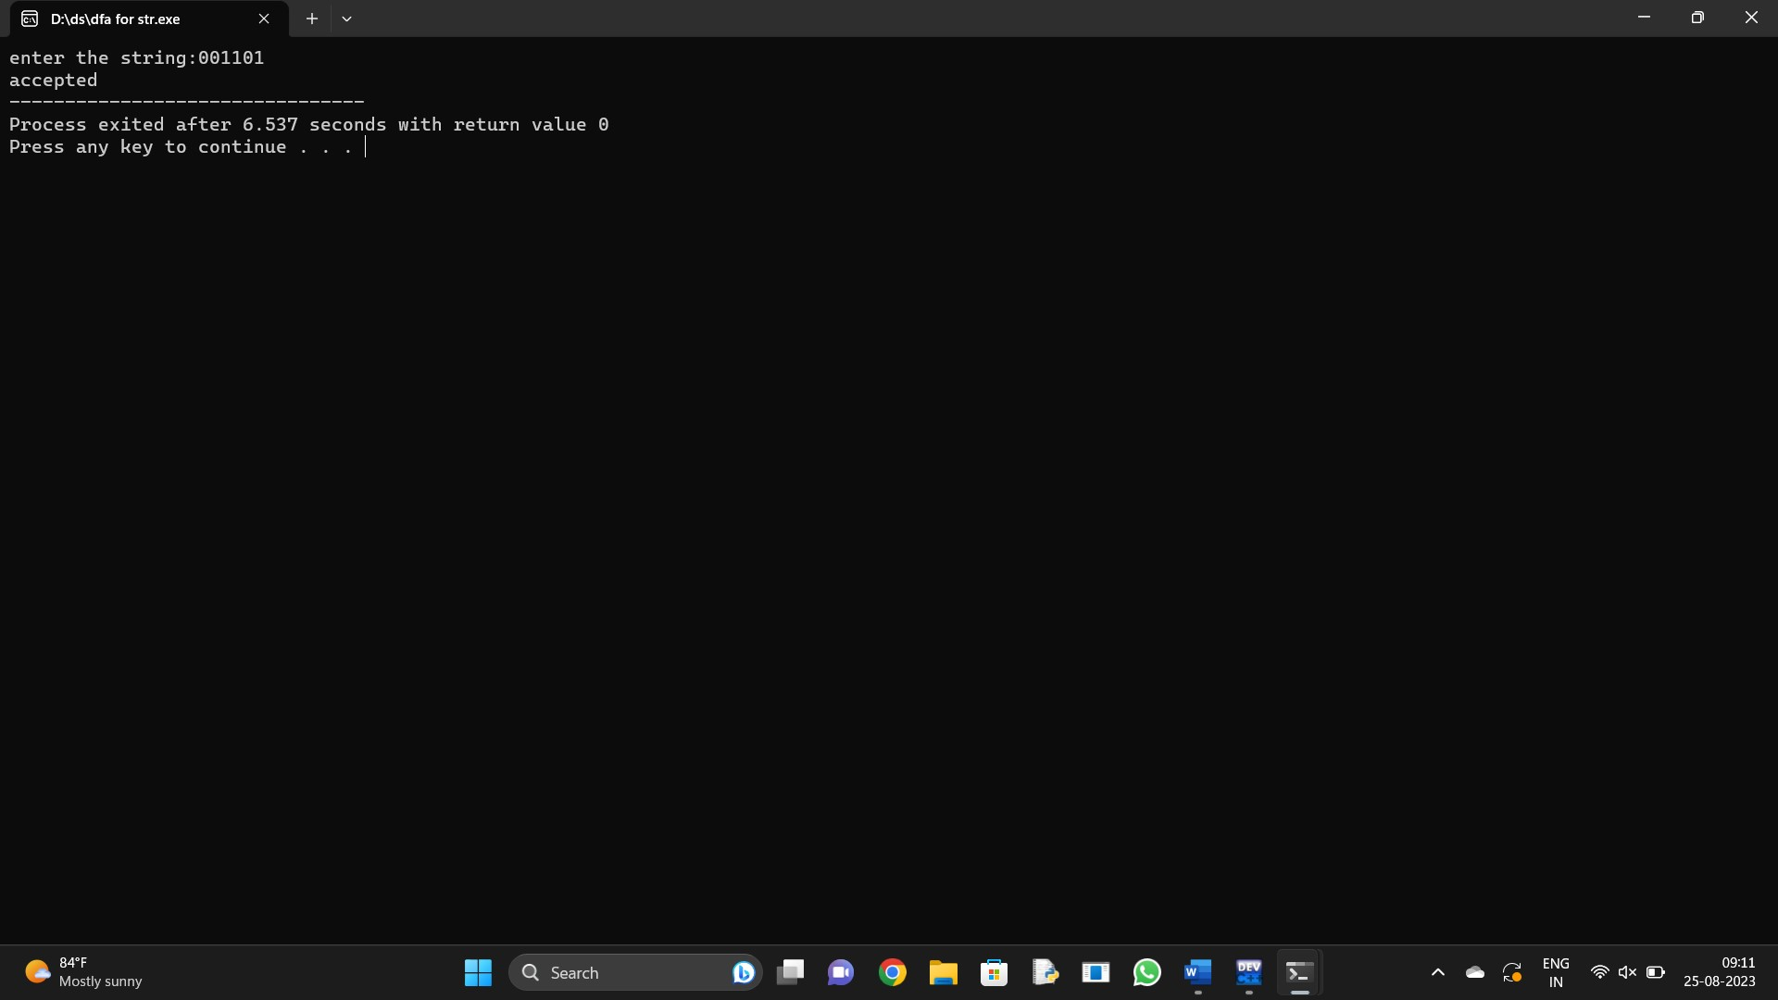

3.Write a C program to check whether a given string belongs to the language defined by a Context Free Grammar (CFG)

S → 0A1 A → 0A | 1A | ε

#include<stdio.h>

#include<string.h>

int main(){

char s[100];

int i,f;

printf("enter the string:");

scanf("%s",&s);

for(i=0;i<strlen(s);i++){

if(s[i]=='0'||s[i]=='1'&&s[0]=='0'&&s[strlen(s-1)=='1']){

printf("accepted");

break;

}

else

printf("not accepted");

break;

}

return 0;

}

Output:

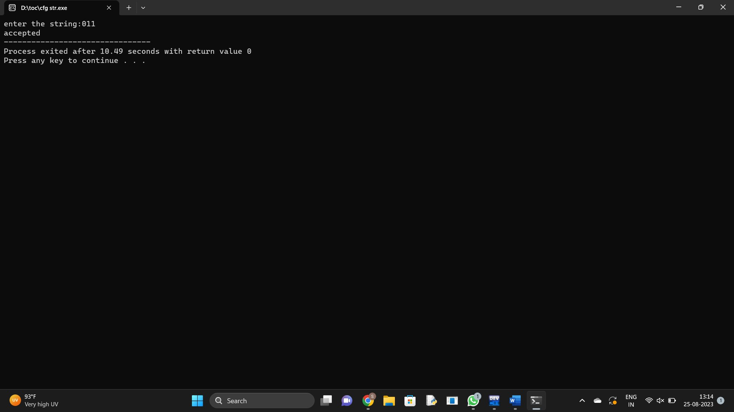

1. Write a C program to check whether a given string belongs to the language defined by a Context Free Grammar (CFG)

S → 0S0 | 1S1 | 0 | 1 | ε

#include<stdio.h>

#include<conio.h>

#include<string.h>

int main(){

char s[100];

int i;

printf("enter the string:");

scanf("%s",&s);

for(i=0;i<strlen(s);i++){

if((s[i]=='0'||s[i]=='1')&&s[0]=='0'&&s[strlen(s)-1]=='0'||s[0]=='1'&&s[strlen(s)-1]=='1'){

printf("accepted");

break;

}

else{

printf("not accepted");

break;

}

}

getch();

}

Output:

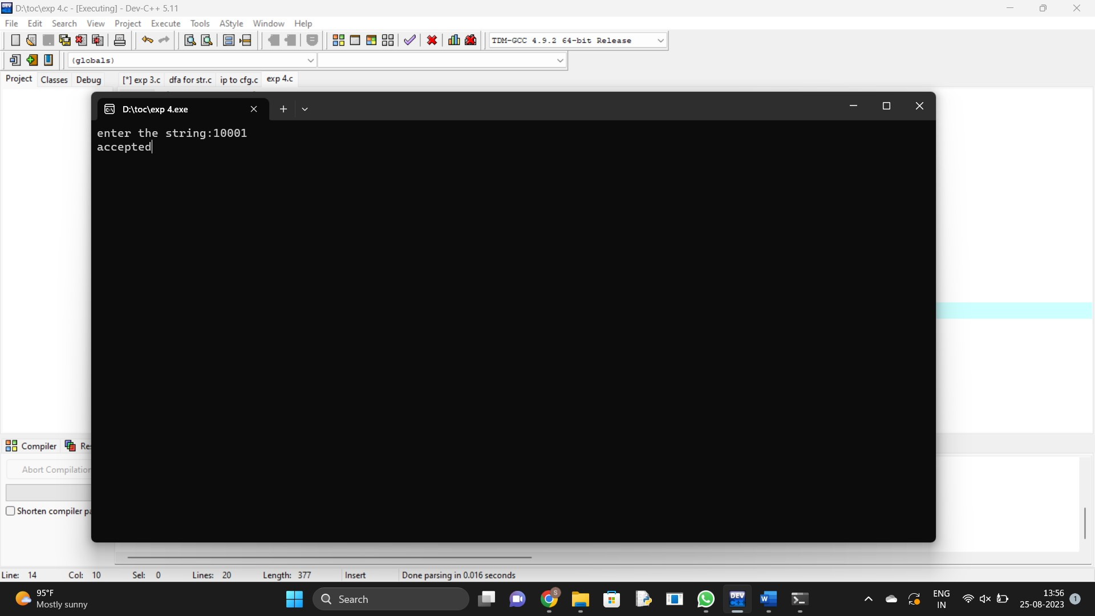

1. Write a C program to check whether a given string belongs to the language defined by a Context Free Grammar (CFG)

S → 0S0 | A A → 1A | ε

#include<stdio.h>

#include<string.h>

int main(){

int i,n,j;

char s[100];

printf("enter the string:");

scanf("%s",&s);

n=strlen(s);

for(i=0;i<n;i++){

if(s[i]=='1'){

printf("accepted");

break;

}

else if(s[0]=='0'&&s[n-1]=='0'){

printf("accepted");

break;

}

else{

printf("not accepted");

break;

}

}

return 0;

}

Output:

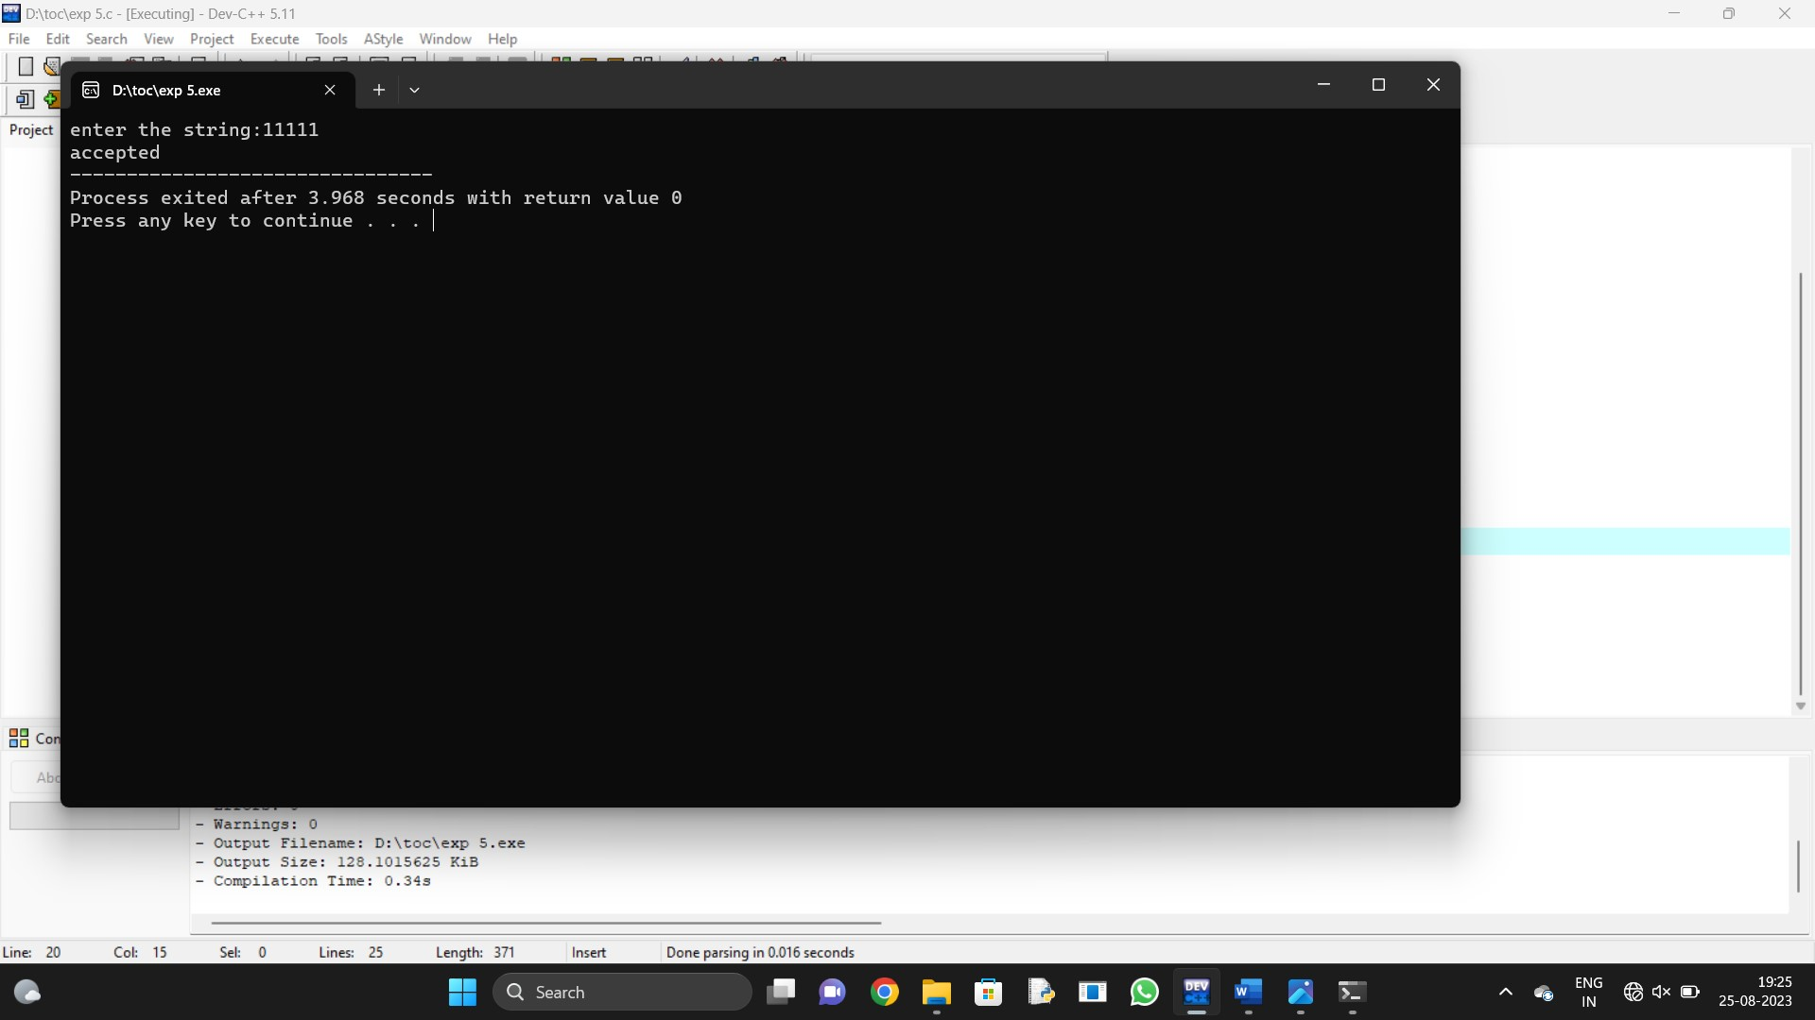

6.Write a C program to check whether a given string belongs to the language defined by a Context Free Grammar (CFG)

S → 0S1 | ε

#include<stdio.h>

#include<string.h>

int main()

{

int i,a=0,b=0;

char s[100];

printf("enter the string:");

scanf("%s",&s);

for(i=0;i<strlen(s);i++){

if(s[i]=='0')

a+=1;

else if(s[i]=='1')

b+=1;

}

if(a==b&&s[0]=='0'&&s[strlen(s)-1]=='1')

printf("accepted");

else

printf("not accepted");

return 0;

}

Output:

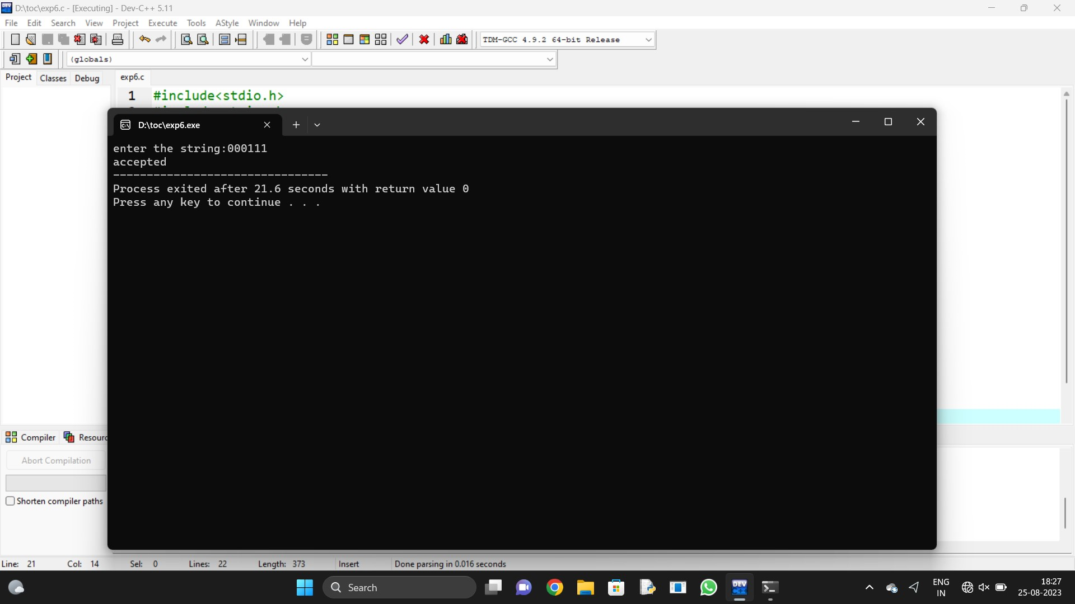

1. Write a C program to check whether a given string belongs to the language defined by a Context Free Grammar (CFG)

S → A101A, A → 0A | 1A | ε

#include<stdio.h>

#include<string.h>

int main()

{

int i,t;

char s[100];

printf("enter the string:");

scanf("%s",&s);

for(i=0;i<strlen(s);i++){

if(s[i]=='0'||s[i]=='1'&&s[i+1]=='1'&&s[i+2]=='0'&&s[i+3]=='1')

t=1;

}

if(t==1)

printf("accepted");

else

printf("not accepted");

return 0;

}

Output:

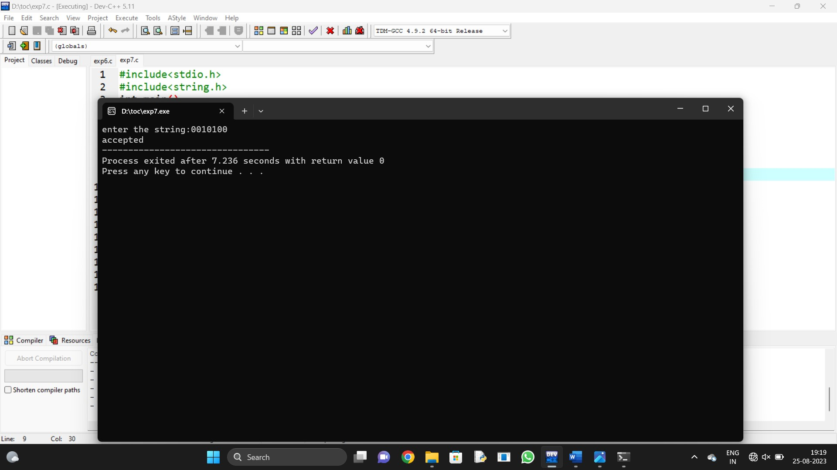

1. Write a C program to simulate a Non-Deterministic Finite Automata (NFA) for the given languagerepresenting strings that start with b and end with a

#include<stdio.h>

#include<string.h>

int main(){

char s[100];

printf("enter the string:");

scanf("%s",&s);

if(s[0]=='b'&&s[strlen(s-1)=='a'])

printf("accepted");

else

printf("not accepted");

return 0;

}

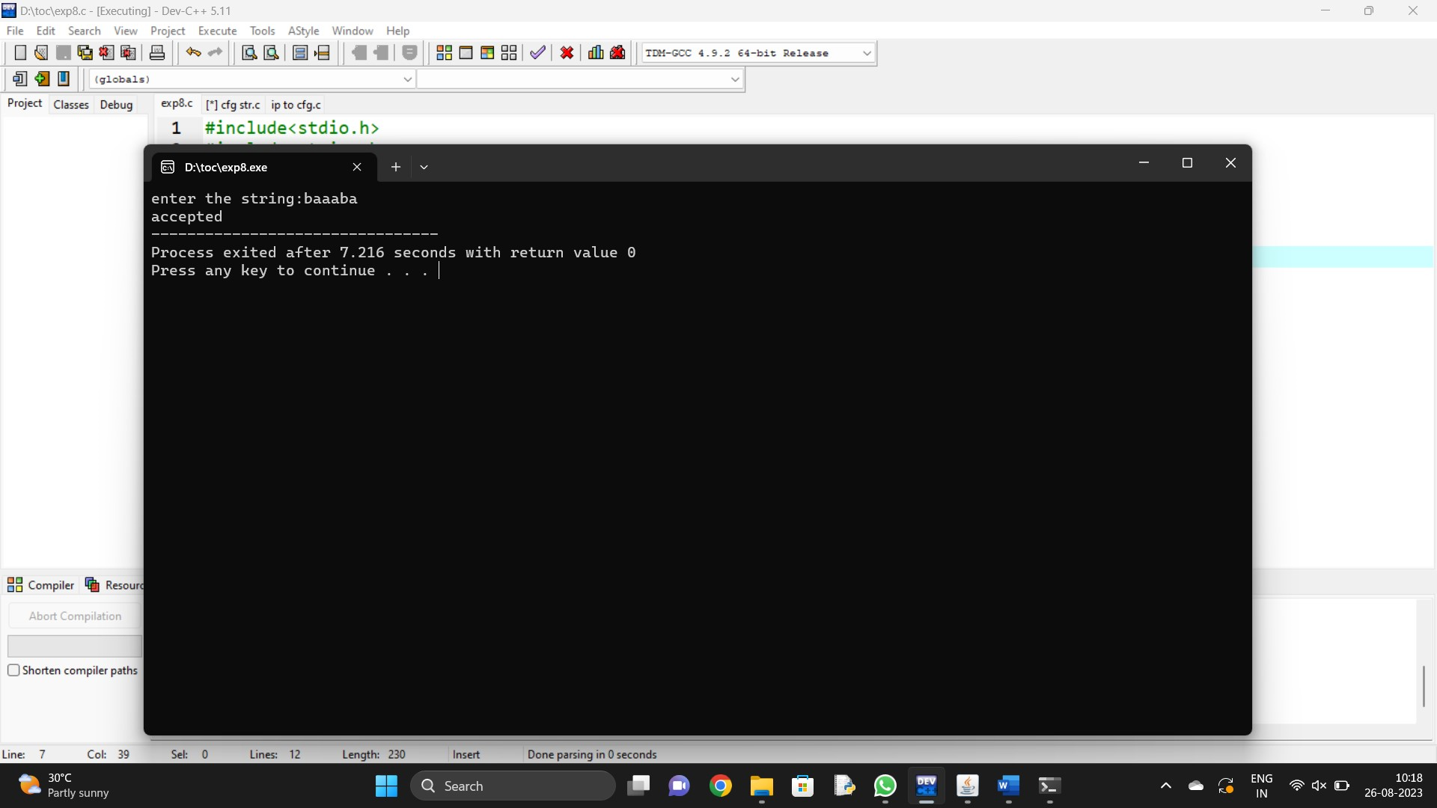

1. Write a C program to simulate a Non-Deterministic Finite Automata (NFA) for the given languagerepresenting strings that start with o and end with 1

#include<stdio.h>

#include<string.h>

int main(){

char s[100];

printf("enter the string:");

scanf("%s",&s);

if(s[0]=='0'&&s[strlen(s-1)=='1'])

printf("accepted");

else

printf("not accepted");

return 0;

}

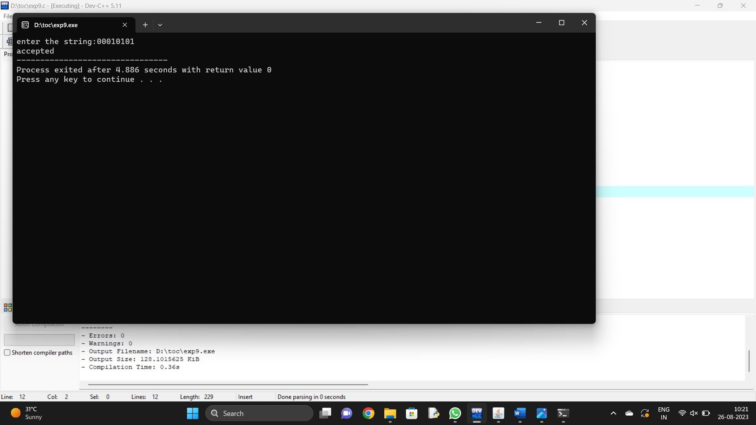

1. Write a C program to find ε -closure for all the states in a Non-Deterministic Finite Automata (NFA) with ε -moves.

#include<stdio.h>

#include<string.h>

int trans_table[10][5][3];

char symbol[5],a;

int e_closure[10][10],ptr,state;

void find_e_closure(int x);

int main()

{

int i,j,k,n,num_states,num_symbols;

for(i=0;i<10;i++)

{

for(j=0;j<5;j++)

{

for(k=0;k<3;k++)

{

trans_table[i][j][k]=-1;

} } }

num_states=3;

num_symbols=2;

symbol[10]='e';

n=1;

trans_table[0][0][0]=1;

for(i=0;i<10;i++)

{

for(j=0;j<10;j++)

{

e_closure[i][j]=-1;

} }

for(i=0;i<num_states;i++)

e_closure[i][0]=i;

for(i=0;i<num_states;i++)

{

if(trans_table[i][0][0]==-1)

continue;

else

{

state=i;

ptr=1;

find_e_closure(i);

} }

for(i=0;i<num_states;i++)

{

printf("e-closure(%d)= {",i);

for(j=0;j<num_states;j++)

{

if(e_closure[i][j]!=-1)

{

printf("%d, ",e_closure[i][j]);

} }

printf("}\n");

} }

void find_e_closure(int x)

{

int i,j,y[10],num_trans;

i=0;

while(trans_table[x][0][i]!=-1)

{

y[i]=trans_table[x][0][i];

i=i+1;

}

num_trans=i;

for(j=0;j<num_trans;j++)

{

e_closure[state][ptr]=y[j];

ptr++;

find_e_closure(y[j]);

} }

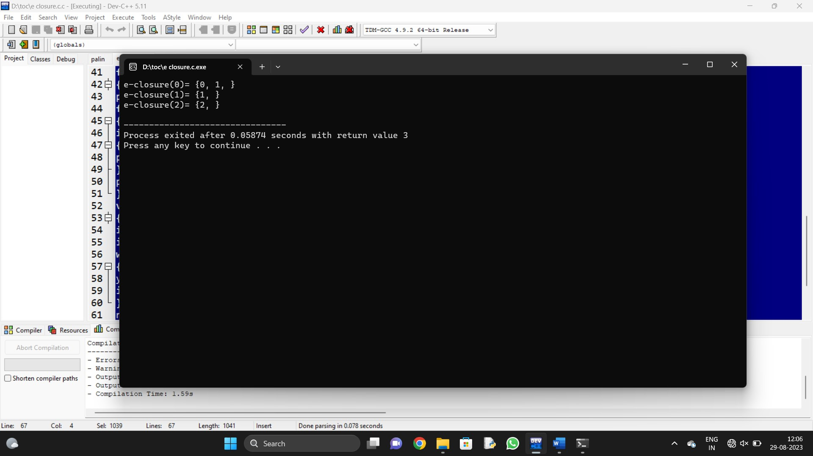

1. Write a C program to find ε -closure for all the states in a Non-Deterministic Finite Automata (NFA) with ε -moves.

#include<stdio.h>

#include<string.h>

int trans_table[10][5][3];

char symbol[5],a;

int e_closure[10][10],ptr,state;

void find_e_closure(int x);

int main()

{

int i,j,k,n,num_states,num_symbols;

for(i=0;i<10;i++)

{

for(j=0;j<5;j++)

{

for(k=0;k<3;k++)

{

trans_table[i][j][k]=-1;

} } }

num_states=3;

num_symbols=2;

symbol[10]='e';

n=1;

trans_table[0][0][0]=1;

for(i=0;i<10;i++)

{

for(j=0;j<10;j++)

{

e_closure[i][j]=-1;

} }

for(i=0;i<num_states;i++)

e_closure[i][0]=i;

for(i=0;i<num_states;i++)

{

if(trans_table[i][0][0]==-1)

continue;

else

{

state=i;

ptr=1;

find_e_closure(i);

} }

for(i=0;i<num_states;i++)

{

printf("e-closure(%d)= {",i);

for(j=0;j<num_states;j++)

{

if(e_closure[i][j]!=-1)

{

printf("%d, ",e_closure[i][j]);

} }

printf("}\n");

} }

void find_e_closure(int x)

{

int i,j,y[10],num_trans;

i=0;

while(trans_table[x][0][i]!=-1)

{

y[i]=trans_table[x][0][i];

i=i+1;

}

num_trans=i;

for(j=0;j<num_trans;j++)

{

e_closure[state][ptr]=y[j];

ptr++;

find_e_closure(y[j]);

} }



1. Design DFA using simulator to accept the input string “a” ,”ac”,and ”bac”.

Automaton Simulator, v1.0

dfa {

alphabet {abcd*}

state {

initial {yes}

final {yes}

coord {404 390}

}

state {

final {yes}

coord {731 405}

}

edge 0 1 {

transits {bc}

offset {0.5235987755982988}

}

edge 0 0 {

transits {a}

offset {2.356194490192345}

}

edge 1 0 {

transits {a}

offset {0.5235987755982988}

}

}

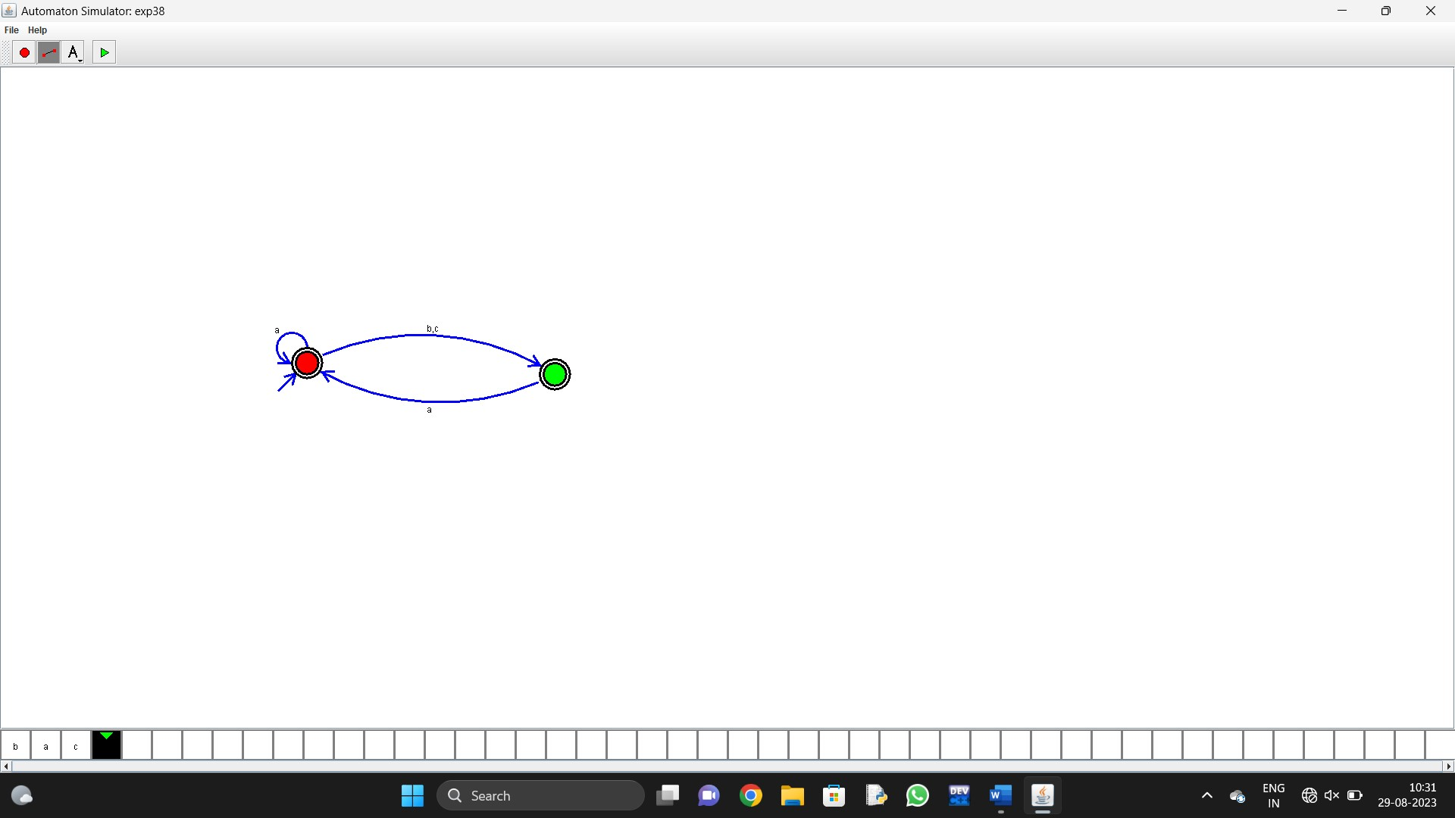

13.Design PDA using simulator to accept the input string aabb

Automaton Simulator, v1.0

dpda {

alphabet {abcd*}

state {

initial {yes}

coord {374 203}

}

state {

coord {565 202}

}

state {

final {yes}

coord {755 189}

}

edge 0 1 {

transits {a}

offset {0.5235987755982988}

action {push a}

}

edge 1 2 {

transits {b}

offset {0.5235987755982988}

stacktop {a}

action {pop}

}

edge 1 1 {

transits {}

offset {2.356194490192345}

}

edge 1 1 {

transits {a}

offset {2.356194490192345}

stacktop {a}

action {push a}

}

edge 2 2 {

transits {b}

offset {2.356194490192345}

stacktop {a}

action {pop}

}

label {

text {}

font {SansSerif 12 -}

coord {378 211}

}

label {

text {}

font {SansSerif 12 -}

coord {570 215}

}

label {

text {}

font {SansSerif 12 -}

coord {758 179}

}

label {

text {}

font {SansSerif 12 -}

coord {765 213}

}

label {

text {}

font {SansSerif 12 -}

coord {743 196}

}

label {

text {}

font {SansSerif 12 -}

coord {743 196}

}

}

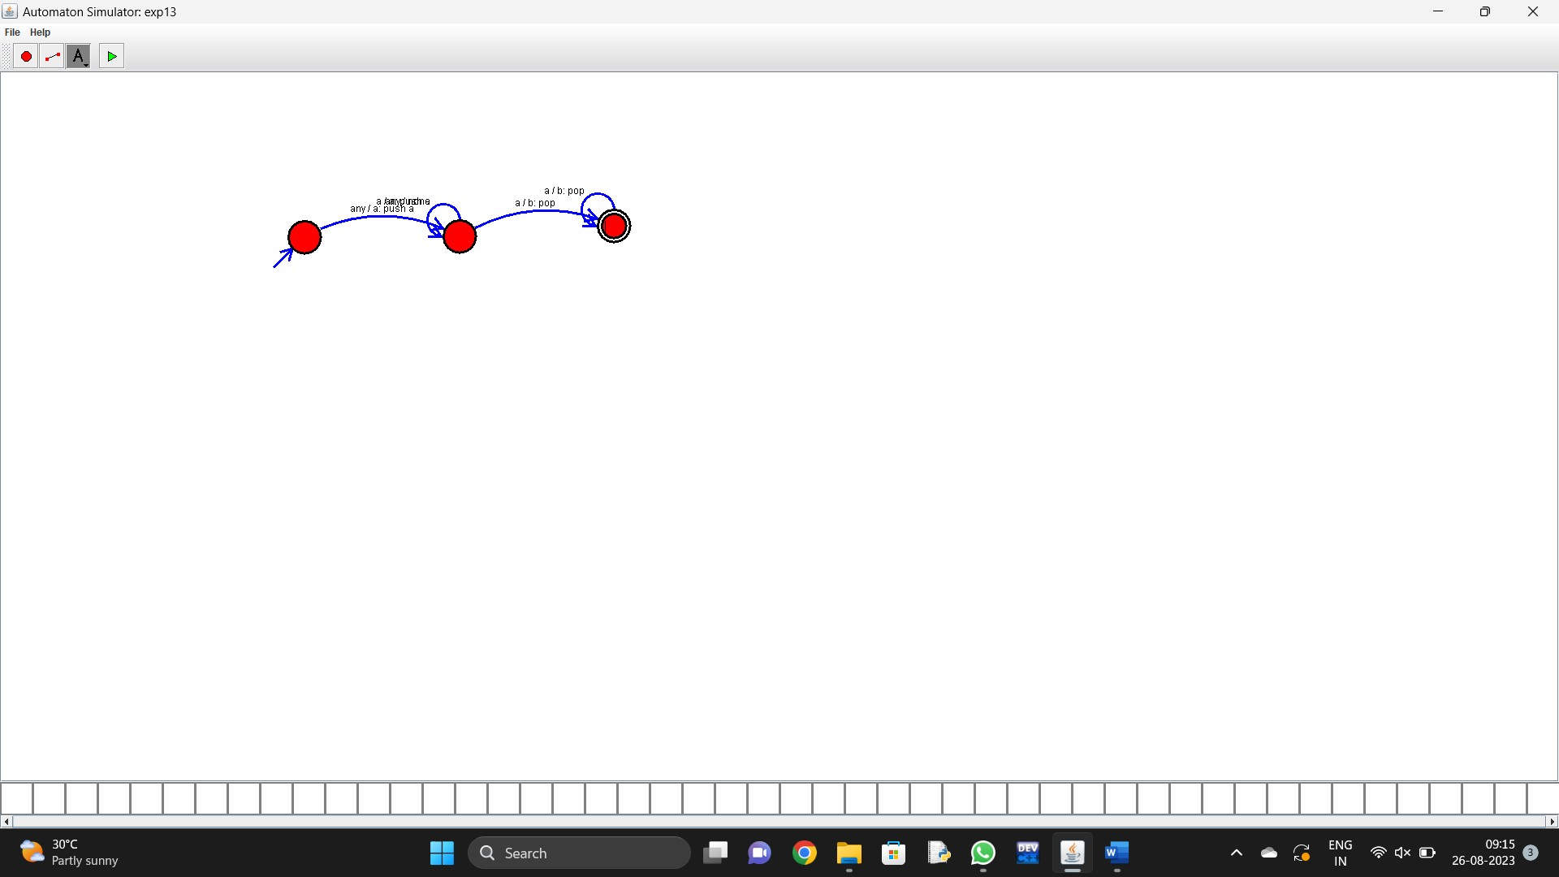

1. Design PDA using simulator to accept the input string anb2n

Automaton Simulator, v1.0

dpda {

alphabet {abcd*}

state {

initial {yes}

coord {375 349}

}

state {

coord {590 352}

}

state {

coord {812 356}

}

edge 0 1 {

transits {a}

offset {-1.3574114378561062}

action {push a}

}

edge 1 2 {

transits {b}

offset {-1.2982484531686527}

stacktop {a}

}

edge 2 1 {

transits {b}

offset {-7.6403203255442484}

stacktop {a}

action {pop}

}

edge 1 1 {

transits {a}

offset {2.5924397509107826}

stacktop {a}

action {push a}

}

}

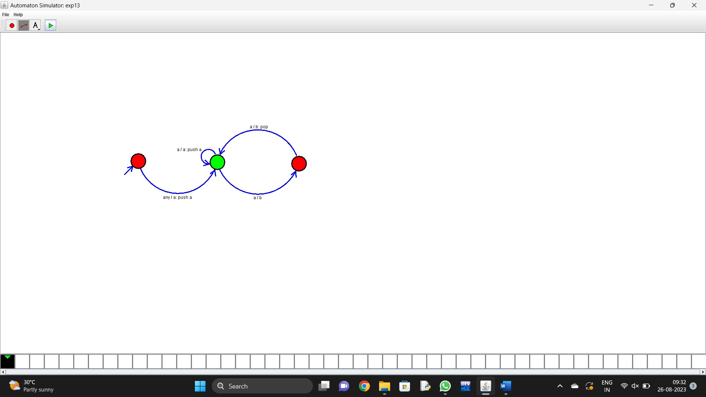

1. Design TM using simulator to accept the input string anbn

Automaton Simulator, v1.0

turing {

alphabet {abcd*_}

state {

initial {yes}

coord {367 382}

}

state {

coord {654 379}

}

state {

final {yes}

coord {1016 380}

}

edge 0 1 {

transits {a}

offset {-0.12102983525327138}

direction {R}

output {c}

}

edge 1 2 {

transits {b}

offset {-0.01618480525091026}

direction {R}

output {d}

}

edge 2 2 {

transits {b}

offset {2.356194490192345}

direction {R}

output {d}

}

edge 1 1 {

transits {a}

offset {2.356194490192345}

direction {R}

output {c}

}

}

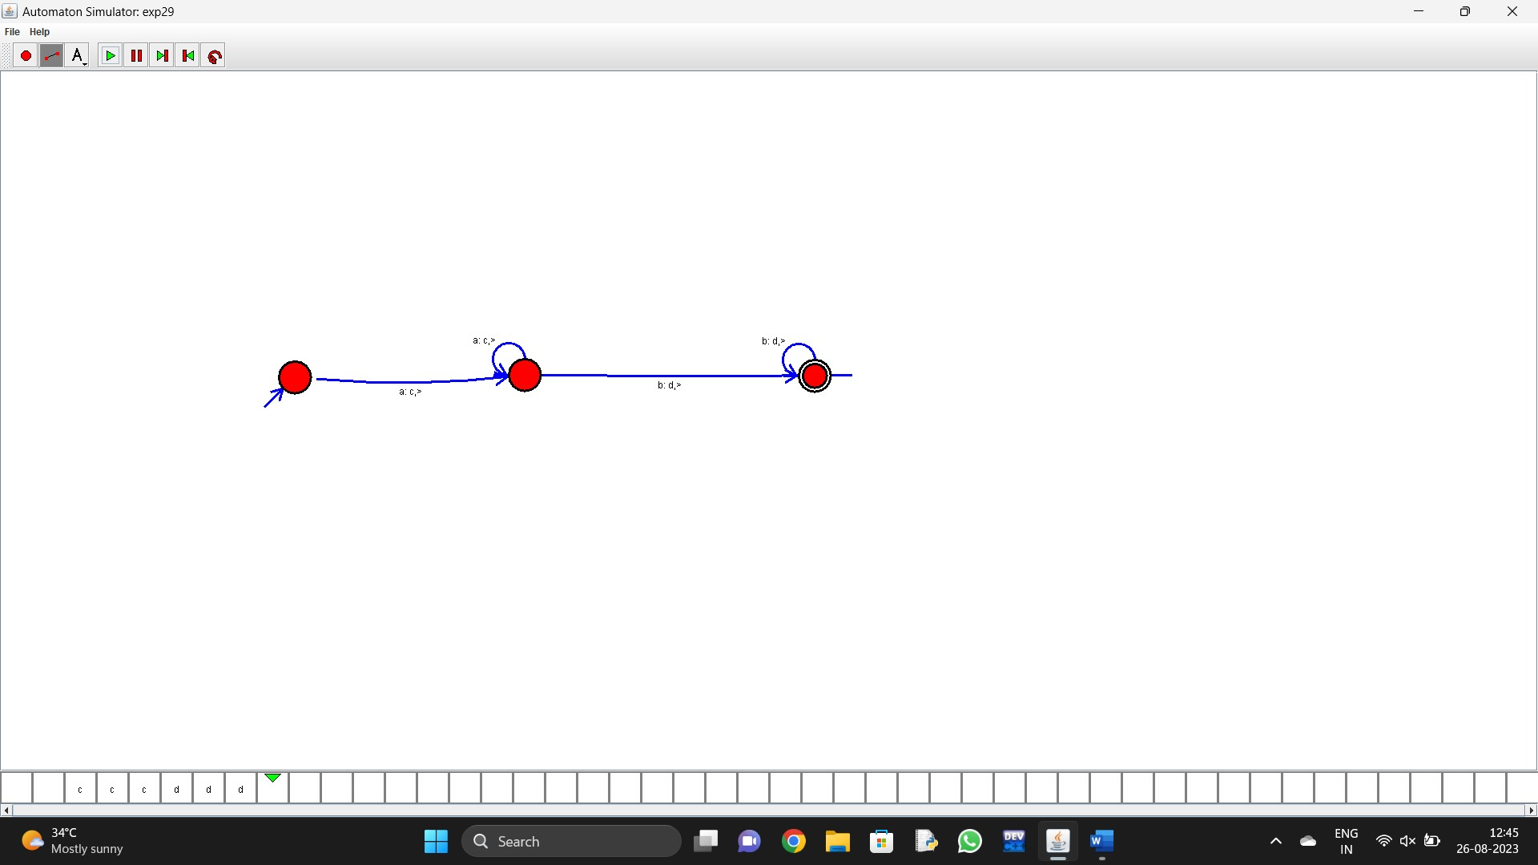

1. Design TM using simulator to accept the input string anb2n

Automaton Simulator, v1.0

turing {

alphabet {abcd*_}

state {

initial {yes}

coord {367 382}

}

state {

coord {654 379}

}

state {

final {yes}

coord {1016 380}

}

edge 0 1 {

transits {a}

offset {-0.12102983525327138}

direction {R}

output {c}

}

edge 1 2 {

transits {b}

offset {-0.01618480525091026}

direction {R}

output {d}

}

edge 2 2 {

transits {b}

offset {2.356194490192345}

direction {R}

output {d}

}

edge 1 1 {

transits {a}

offset {2.356194490192345}

direction {R}

output {c}

}

}

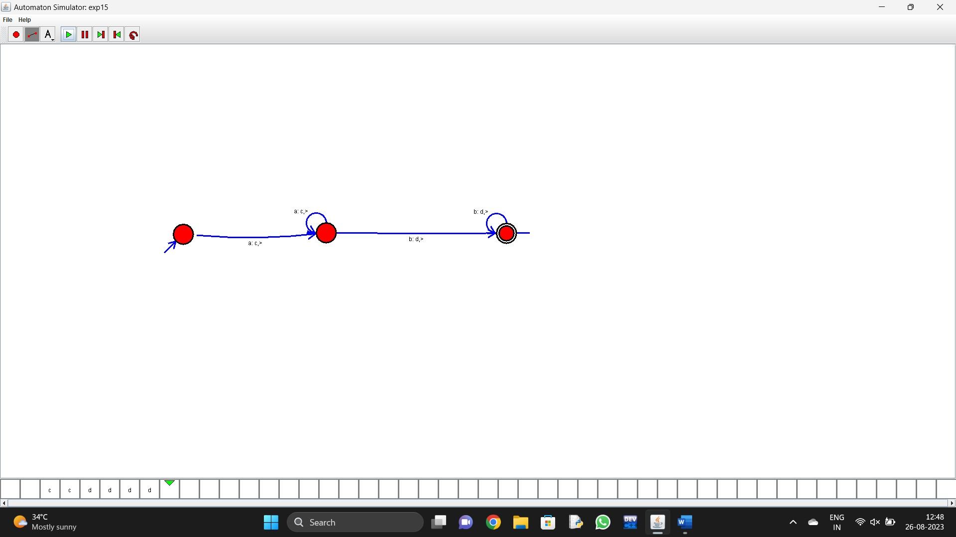

1. Design TM using simulator to accept the input string Palindrome ababa

Automaton Simulator, v1.0

turing {

alphabet {abcd*_}

state {

initial {yes}

final {yes}

coord {359 327}

}

state {

coord {612 324}

}

state {

coord {960 343}

}

edge 0 1 {

transits {a}

offset {0.056476652233853446}

direction {R}

output {c}

}

edge 1 1 {

transits {a}

offset {2.356194490192345}

direction {R}

output {c}

}

edge 1 2 {

transits {b}

offset {0.5235987755982988}

direction {R}

output {d}

}

edge 2 0 {

transits {a}

offset {0.8664942535490674}

direction {R}

output {c}

}

edge 2 1 {

transits {b}

offset {0.5235987755982988}

direction {R}

output {d}

}

edge 0 1 {

transits {b}

offset {0.5235987755982988}

direction {R}

output {d}

}

}

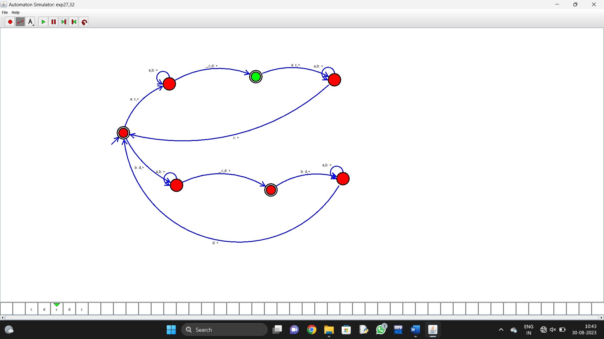

1. Design TM using simulator to accept the input string ww

Automaton Simulator, v1.0

turing {

alphabet {abcd*_}

state {

initial {yes}

coord {419 365}

}

state {

coord {611 374}

}

state {

coord {823 368}

}

state {

final {yes}

coord {828 593}

}

edge 0 1 {

transits {a}

offset {0.04908752783264243}

direction {R}

output {c}

}

edge 1 2 {

transits {b}

offset {0.672166180632624}

direction {L}

output {d}

}

edge 1 1 {

transits {ad}

offset {2.356194490192345}

direction {R}

}

edge 2 3 {

transits {ad}

offset {0.5235987755982988}

direction {L}

}

edge 3 0 {

transits {c}

offset {0.5235987755982988}

direction {R}

}

edge 3 3 {

transits {ad}

offset {2.356194490192345}

direction {L}

}

edge 0 0 {

transits {cd}

offset {2.356194490192345}

direction {R}

}

edge 1 3 {

transits {_}

offset {0.5235987755982988}

direction {L}

}

}

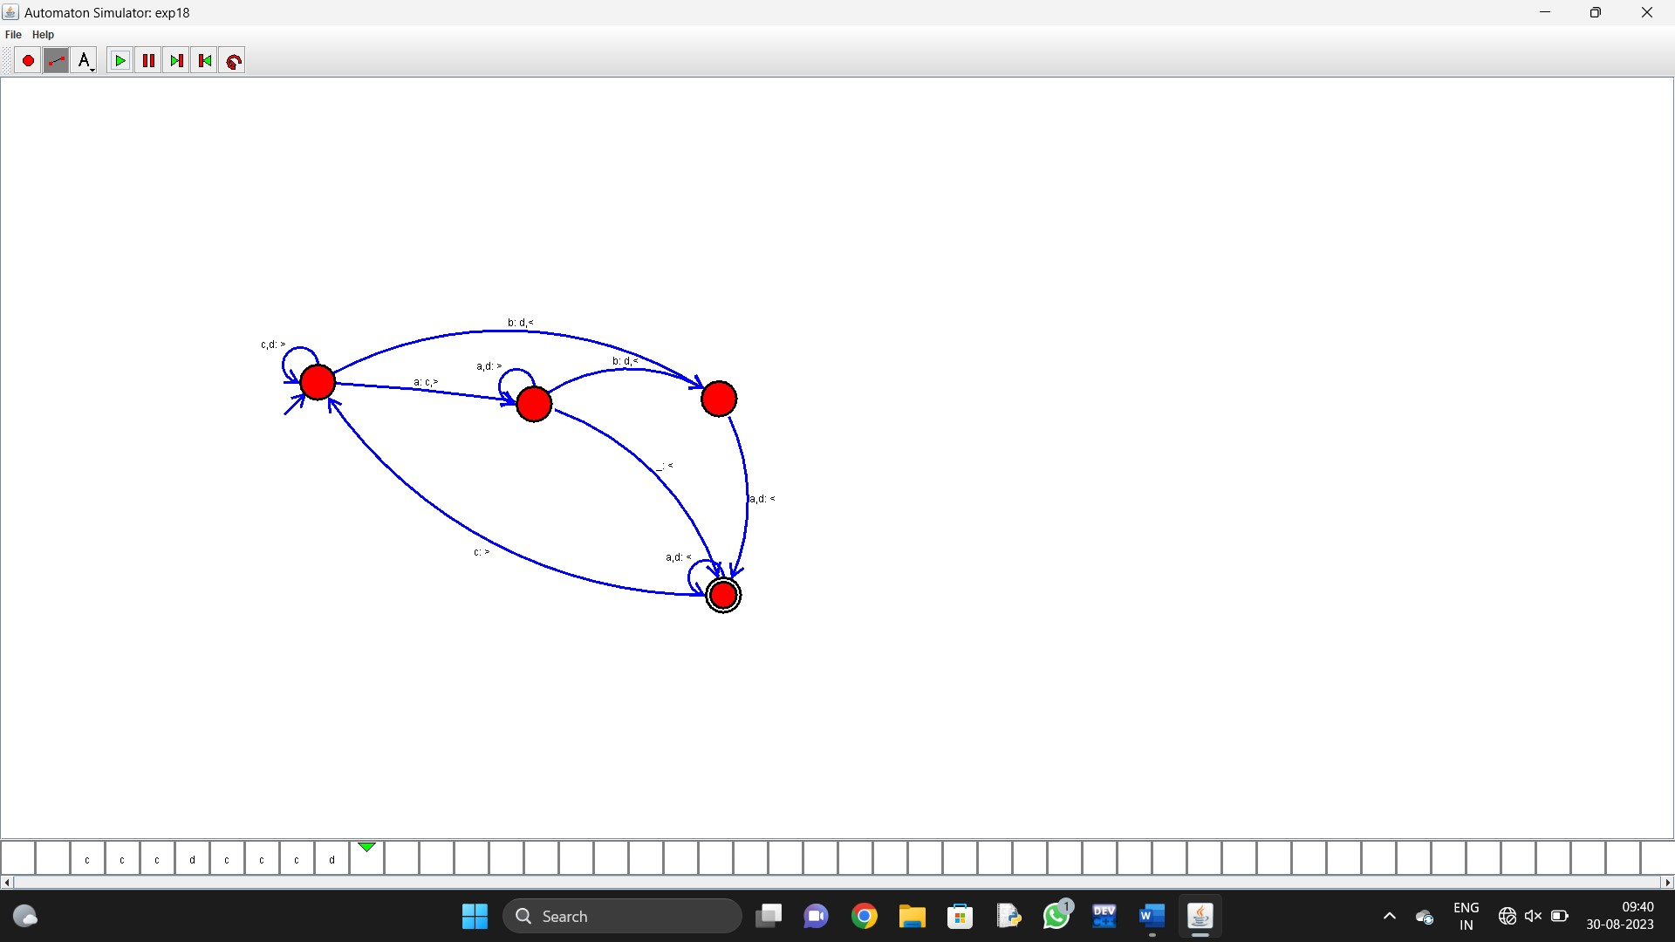

1. Design TM using simulator to perform addition of ‘aa’ and ‘aaa’

Automaton Simulator, v1.0

turing {

alphabet {abcd*_}

state {

initial {yes}

coord {414 377}

}

state {

coord {667 369}

}

state {

coord {874 372}

}

state {

coord {815 555}

}

state {

coord {679 586}

}

state {

coord {1058 325}

}

state {

final {yes}

coord {1014 230}

}

edge 0 1 {

transits {a}

offset {0.5235987755982988}

direction {R}

}

edge 1 2 {

transits {c}

offset {0.6082726486161775}

direction {R}

}

edge 1 1 {

transits {a}

offset {2.356194490192345}

direction {R}

}

edge 2 3 {

transits {a}

offset {0.5235987755982988}

direction {L}

output {c}

}

edge 3 4 {

transits {c}

offset {0.5235987755982988}

direction {R}

output {a}

}

edge 2 5 {

transits {_}

offset {0.5235987755982988}

direction {L}

}

edge 5 6 {

transits {c}

offset {0.5235987755982988}

direction {L}

output {_}

}

edge 4 2 {

transits {c}

offset {0.5235987755982988}

direction {R}

}

}

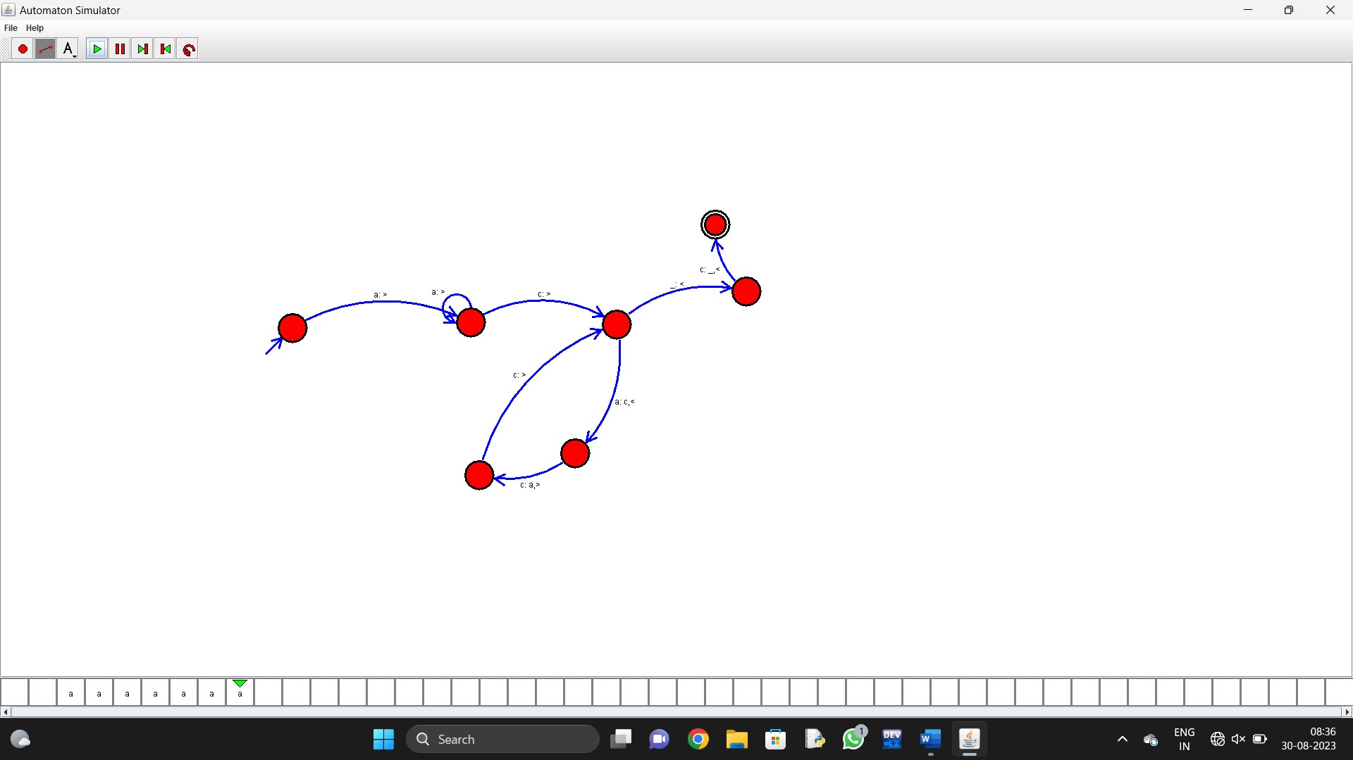

1. Design TM using simulator to perform subtraction of aaa-aa

Automaton Simulator, v1.0

turing {

alphabet {abcd*_}

state {

initial {yes}

coord {338 250}

}

state {

coord {665 243}

}

state {

coord {895 238}

}

state {

coord {914 431}

}

state {

final {yes}

coord {1153 206}

}

state {

coord {324 423}

}

state {

coord {155 483}

}

state {

coord {196 161}

}

edge 0 1 {

transits {a}

offset {-0.06368046424852797}

direction {R}

}

edge 1 1 {

transits {ac}

offset {2.356194490192345}

direction {R}

}

edge 1 2 {

transits {_}

offset {0.132551532296674}

direction {L}

}

edge 2 3 {

transits {a}

offset {0.5235987755982988}

direction {L}

output {_}

}

edge 3 3 {

transits {a}

offset {2.356194490192345}

direction {L}

}

edge 2 4 {

transits {c}

offset {0.5235987755982988}

direction {L}

output {_}

}

edge 3 5 {

transits {c}

offset {0.5235987755982988}

direction {L}

}

edge 5 6 {

transits {a}

offset {0.5235987755982988}

direction {L}

}

edge 6 6 {

transits {a}

offset {2.356194490192345}

direction {L}

}

edge 7 0 {

transits {a}

offset {0.5235987755982988}

direction {R}

output {_}

}

edge 6 7 {

transits {_}

offset {0.5235987755982988}

direction {R}

}

}

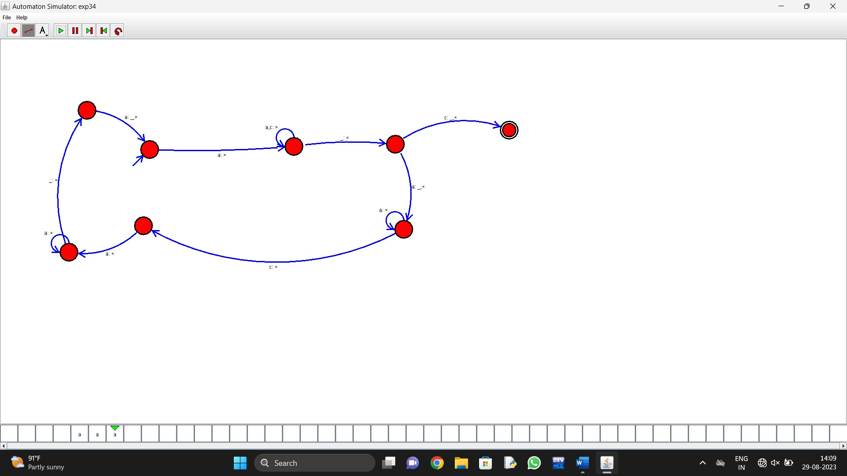

21. Design DFA using simulator to accept even number of a’s.

Automaton Simulator, v1.0

dfa {

alphabet {abcd*}

state {

initial {yes}

final {yes}

coord {471 419}

}

state {

coord {914 417}

}

edge 1 1 {

transits {b}

offset {2.356194490192345}

}

edge 0 1 {

transits {a}

offset {0.027106336758020856}

}

edge 1 0 {

transits {a}

offset {6.969663675555964}

}

edge 0 0 {

transits {b}

offset {2.356194490192345}

}

}

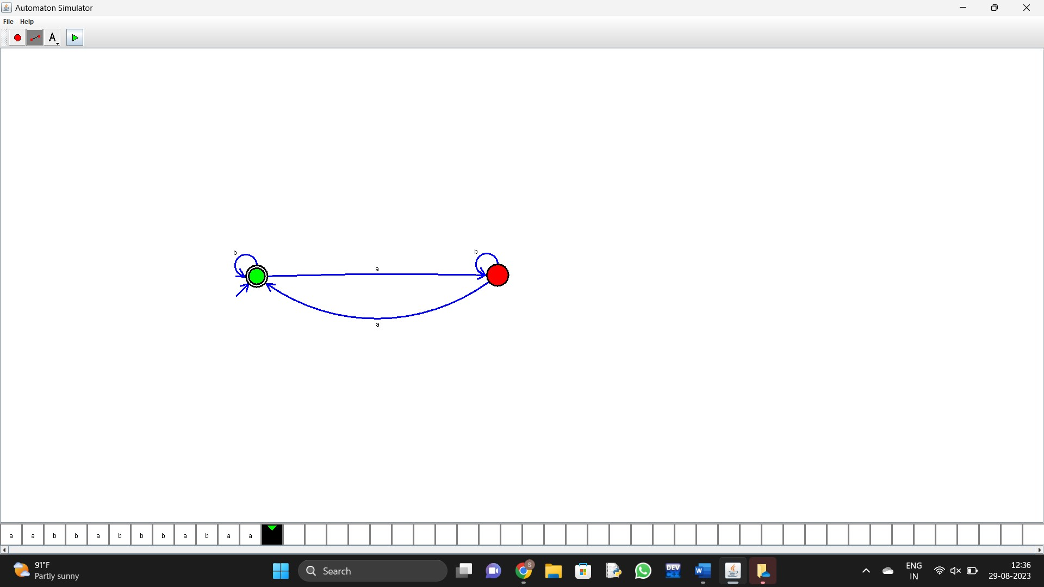

1. Design DFA using simulator to accept odd number of a’s

Automaton Simulator, v1.0

dfa {

alphabet {abcd*}

state {

initial {yes}

coord {437 403}

}

state {

final {yes}

coord {606 407}

}

edge 0 1 {

transits {a}

offset {0.5235987755982988}

}

edge 0 0 {

transits {b}

offset {2.356194490192345}

}

edge 1 1 {

transits {b}

offset {2.356194490192345}

}

edge 1 0 {

transits {a}

offset {0.5235987755982988}

}

}

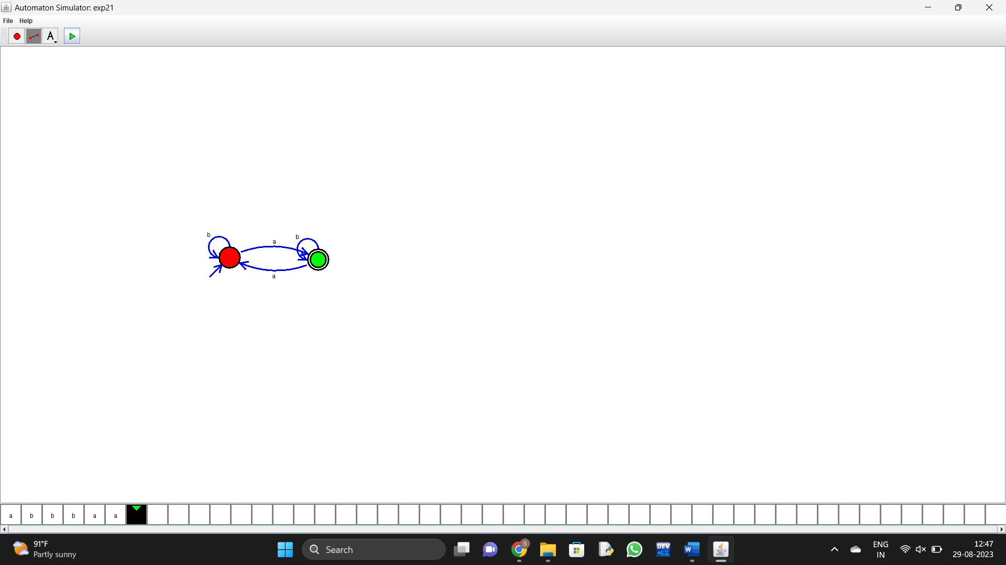

1. Design DFA using simulator to accept the string having ‘ab’ as substring over the set {a,b}

Automaton Simulator, v1.0

dfa {

alphabet {abcd*}

state {

initial {yes}

coord {351 310}

}

state {

final {yes}

coord {708 328}

}

state {

coord {533 324}

}

edge 0 0 {

transits {b}

offset {2.356194490192345}

}

edge 2 2 {

transits {a}

offset {2.356194490192345}

}

edge 1 1 {

transits {ab}

offset {2.356194490192345}

}

edge 0 2 {

transits {a}

offset {-0.11126356752551123}

}

edge 2 1 {

transits {b}

offset {0.05994872695953377}

}

}

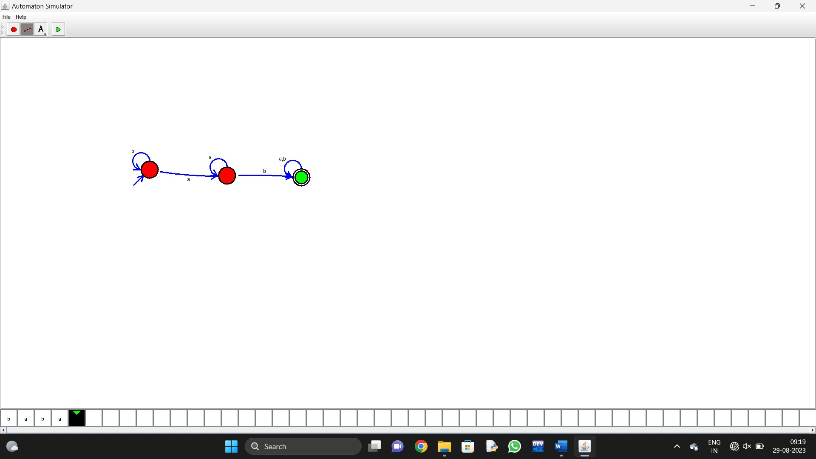

24. Design DFA using simulator to accept the string having ‘ab’ as substring over the set {a,b}

Automaton Simulator, v1.0

dfa {

alphabet {abcd*}

state {

initial {yes}

coord {351 310}

}

state {

final {yes}

coord {708 328}

}

state {

coord {533 324}

}

edge 0 0 {

transits {b}

offset {2.356194490192345}

}

edge 2 2 {

transits {a}

offset {2.356194490192345}

}

edge 1 1 {

transits {ab}

offset {2.356194490192345}

}

edge 0 2 {

transits {a}

offset {-0.11126356752551123}

}

edge 2 1 {

transits {b}

offset {0.05994872695953377}

}

}

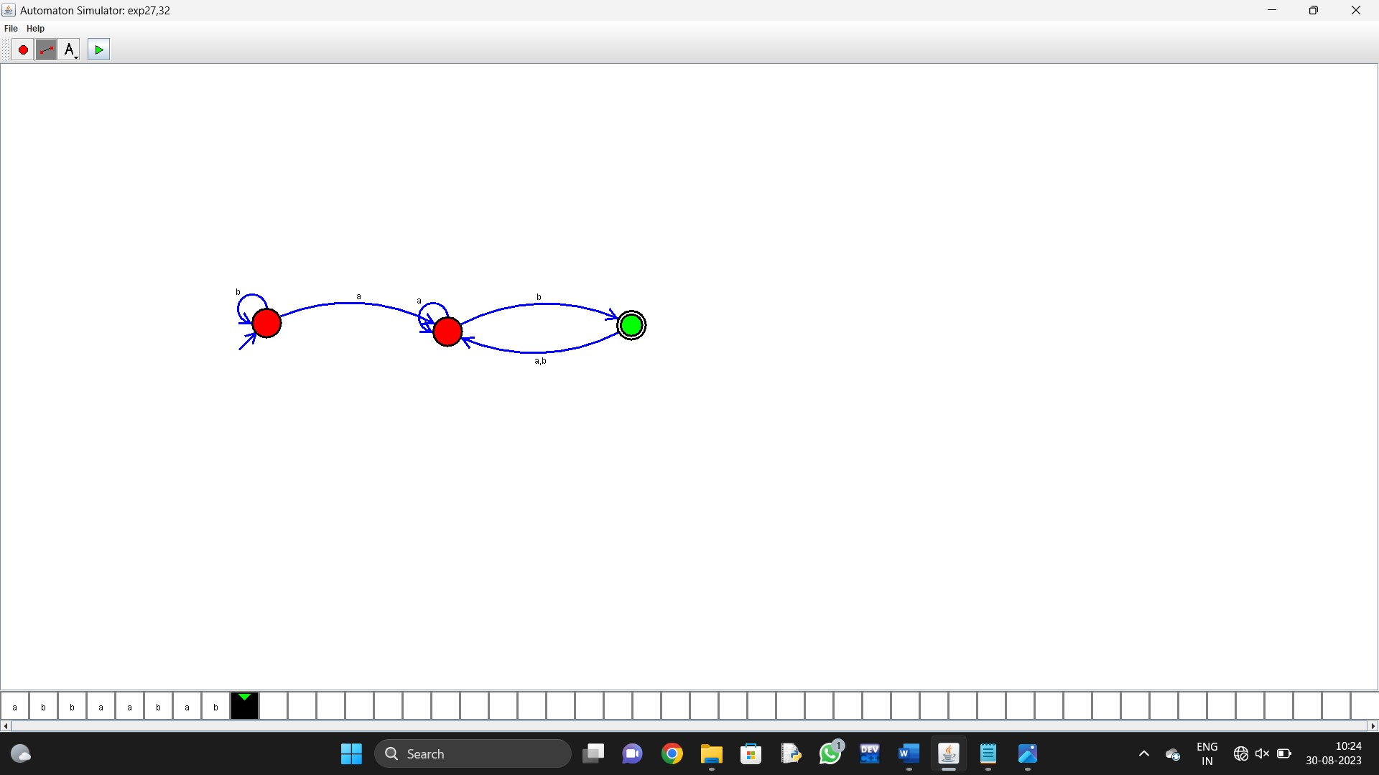

1. Design DFA using simulator to accept the string start with a or b over the set {a,b}

Automaton Simulator, v1.0

dfa {

alphabet {abcd*}

state {

initial {yes}

coord {351 310}

}

state {

final {yes}

coord {708 328}

}

state {

coord {533 324}

}

edge 0 0 {

transits {b}

offset {2.356194490192345}

}

edge 2 2 {

transits {a}

offset {2.356194490192345}

}

edge 1 1 {

transits {ab}

offset {2.356194490192345}

}

edge 0 2 {

transits {a}

offset {-0.11126356752551123}

}

edge 2 1 {

transits {b}

offset {0.05994872695953377}

}

}



1. Design TM using simulator to accept the input string Palindrome bbabb

Automaton Simulator, v1.0

turing {

alphabet {abcd*_}

state {

initial {yes}

final {yes}

coord {391 334}

}

state {

coord {537 178}

}

state {

coord {560 501}

}

state {

final {yes}

coord {860 516}

}

state {

final {yes}

coord {812 155}

}

state {

coord {1062 165}

}

state {

coord {1089 480}

}

edge 0 1 {

transits {a}

offset {0.5235987755982988}

direction {R}

output {c}

}

edge 1 1 {

transits {ab}

offset {2.356194490192345}

direction {R}

}

edge 1 4 {

transits {_cd}

offset {0.5235987755982988}

direction {L}

}

edge 4 5 {

transits {a}

offset {0.5235987755982988}

direction {L}

output {c}

}

edge 5 5 {

transits {ab}

offset {2.356194490192345}

direction {L}

}

edge 5 0 {

transits {c}

offset {0.5235987755982988}

direction {R}

}

edge 0 2 {

transits {b}

offset {-0.38923889274597356}

direction {R}

output {d}

}

edge 2 2 {

transits {ab}

offset {2.356194490192345}

direction {R}

}

edge 2 3 {

transits {_cd}

offset {0.5766553804799897}

direction {L}

}

edge 3 6 {

transits {b}

offset {0.5235987755982988}

direction {L}

output {d}

}

edge 6 6 {

transits {ab}

offset {2.356194490192345}

direction {L}

}

edge 6 0 {

transits {d}

offset {1.3052903714139439}

direction {R}

}

}



27. Design TM using simulator to accept the input string wcw

Automaton Simulator, v1.0

turing {

alphabet {abcd*_}

state {

initial {yes}

coord {426 458}

}

state {

coord {585 379}

}

state {

coord {829 377}

}

state {

coord {537 575}

}

state {

coord {756 580}

}

state {

coord {998 585}

}

state {

coord {1000 387}

}

state {

coord {591 768}

}

state {

coord {706 176}

}

state {

final {yes}

coord {326 388}

}

edge 0 1 {

transits {a}

offset {0.15835042230096566}

direction {R}

output {_}

}

edge 1 1 {

transits {ab}

offset {2.356194490192345}

direction {R}

}

edge 1 2 {

transits {c}

offset {0.07108744278664036}

direction {R}

}

edge 0 3 {

transits {b}

offset {0.5235987755982988}

direction {R}

output {_}

}

edge 3 3 {

transits {ab}

offset {2.5615898793821126}

direction {R}

}

edge 3 4 {

transits {c}

offset {0.5235987755982988}

direction {R}

}

edge 2 6 {

transits {a}

offset {-0.04218322794608522}

direction {L}

output {_}

}

edge 4 5 {

transits {b}

offset {0.5235987755982988}

direction {L}

output {_}

}

edge 6 8 {

transits {c}

offset {-7.15369774054321}

direction {L}

}

edge 8 0 {

transits {_}

offset {-0.6774505621563471}

direction {R}

}

edge 8 8 {

transits {ab}

offset {2.356194490192345}

direction {L}

}

edge 7 0 {

transits {_}

offset {0.7801172661434128}

direction {R}

}

edge 5 7 {

transits {c}

offset {0.5235987755982988}

direction {L}

}

edge 7 7 {

transits {ab}

offset {2.356194490192345}

direction {L}

}

edge 2 2 {

transits {_}

offset {2.356194490192345}

direction {R}

}

edge 4 4 {

transits {_}

offset {2.356194490192345}

direction {R}

}

edge 5 5 {

transits {_}

offset {2.356194490192345}

direction {L}

}

edge 6 6 {

transits {_}

offset {2.356194490192345}

direction {L}

}

edge 0 9 {

transits {c}

offset {0.5235987755982988}

direction {R}

output {d}

}

}

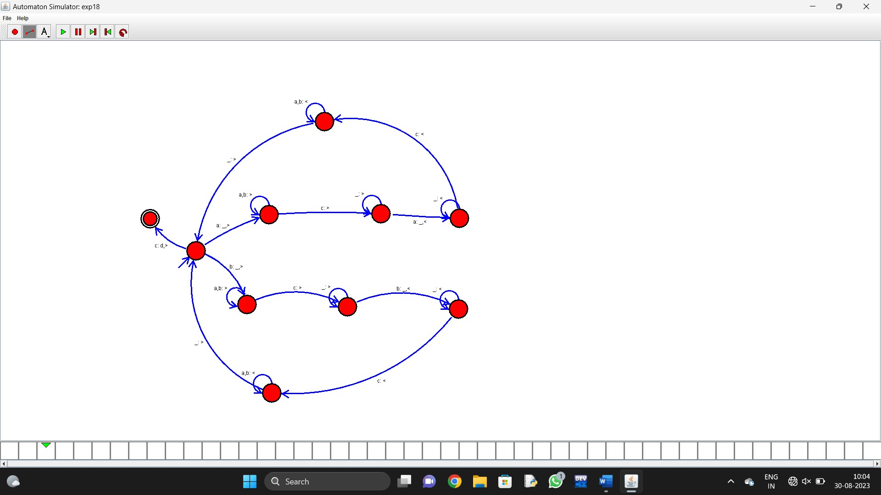

1. Design DFA using simulator to accept the string the end with ab over set {a,b)

W= abbaabab

Automaton Simulator, v1.0

dfa {

alphabet {abcd*}

state {

initial {yes}

coord {351 310}

}

state {

final {yes}

coord {708 328}

}

state {

coord {533 324}

}

edge 0 0 {

transits {b}

offset {2.356194490192345}

}

edge 2 2 {

transits {a}

offset {2.356194490192345}

}

edge 1 1 {

transits {ab}

offset {2.356194490192345}

}

edge 0 2 {

transits {a}

offset {-0.11126356752551123}

}

edge 2 1 {

transits {b}

offset {0.05994872695953377}

}

}



1. Design DFA using simulator to accept the input string “bc” ,”c”,and ”bcaaa”.

Automaton Simulator, v1.0

dfa {

alphabet {abcd*}

state {

initial {yes}

coord {444 344}

}

state {

coord {731 337}

}

state {

coord {982 336}

}

state {

coord {1226 341}

}

edge 0 1 {

transits {b}

offset {-0.06961805221969836}

}

edge 1 2 {

transits {c}

offset {0.03974528884858668}

}

edge 2 3 {

transits {a}

offset {0.10577459196683564}

}

edge 0 0 {

transits {c}

offset {2.356194490192345}

}

edge 3 3 {

transits {a}

offset {2.3779301970341375}

}

}



1. Design NFA to accept any number of a’s where input={a,b}.

Automaton Simulator, v1.0

nfa {

alphabet {abcd*@}

state {

initial {yes}

final {yes}

coord {518 338}

}

state {

final {yes}

coord {825 330}

}

edge 0 0 {

transits {a}

offset {2.356194490192345}

}

edge 0 1 {

transits {b}

offset {0.5153751527287771}

}

edge 1 0 {

transits {a}

offset {0.5235987755982988}

}

edge 1 1 {

transits {b}

offset {2.356194490192345}

}

}

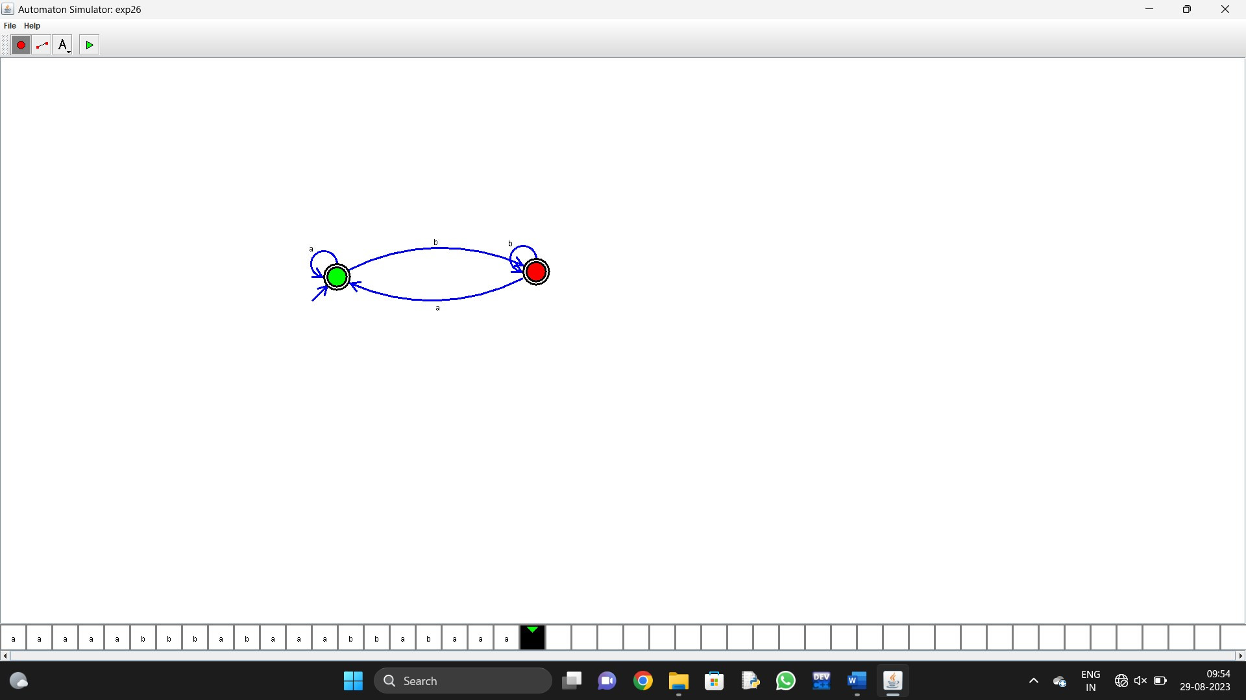

1. Design PDA using simulator to accept the input string anbn

Automaton Simulator, v1.0

dpda {

alphabet {abcd*}

state {

initial {yes}

coord {374 203}

}

state {

coord {565 202}

}

state {

final {yes}

coord {755 189}

}

edge 0 1 {

transits {a}

offset {0.5235987755982988}

action {push a}

}

edge 1 2 {

transits {b}

offset {0.5235987755982988}

stacktop {a}

action {pop}

}

edge 1 1 {

transits {}

offset {2.356194490192345}

}

edge 1 1 {

transits {a}

offset {2.356194490192345}

stacktop {a}

action {push a}

}

edge 2 2 {

transits {b}

offset {2.356194490192345}

stacktop {a}

action {pop}

}

label {

text {}

font {SansSerif 12 -}

coord {378 211}

}

label {

text {}

font {SansSerif 12 -}

coord {570 215}

}

label {

text {}

font {SansSerif 12 -}

coord {758 179}

}

label {

text {}

font {SansSerif 12 -}

coord {765 213}

}

label {

text {}

font {SansSerif 12 -}

coord {743 196}

}

label {

text {}

font {SansSerif 12 -}

coord {743 196}

}

}



1. Design TM using simulator to perform string comparison where w={aba aba}

Automaton Simulator, v1.0

turing {

alphabet {abcd*_}

state {

initial {yes}

coord {426 458}

}

state {

coord {585 379}

}

state {

coord {829 377}

}

state {

coord {537 575}

}

state {

coord {756 580}

}

state {

coord {998 585}

}

state {

coord {1000 387}

}

state {

coord {591 768}

}

state {

coord {706 176}

}

state {

final {yes}

coord {326 388}

}

edge 0 1 {

transits {a}

offset {0.15835042230096566}

direction {R}

output {_}

}

edge 1 1 {

transits {ab}

offset {2.356194490192345}

direction {R}

}

edge 1 2 {

transits {c}

offset {0.07108744278664036}

direction {R}

}

edge 0 3 {

transits {b}

offset {0.5235987755982988}

direction {R}

output {_}

}

edge 3 3 {

transits {ab}

offset {2.5615898793821126}

direction {R}

}

edge 3 4 {

transits {c}

offset {0.5235987755982988}

direction {R}

}

edge 2 6 {

transits {a}

offset {-0.04218322794608522}

direction {L}

output {_}

}

edge 4 5 {

transits {b}

offset {0.5235987755982988}

direction {L}

output {_}

}

edge 6 8 {

transits {c}

offset {-7.15369774054321}

direction {L}

}

edge 8 0 {

transits {_}

offset {-0.6774505621563471}

direction {R}

}

edge 8 8 {

transits {ab}

offset {2.356194490192345}

direction {L}

}

edge 7 0 {

transits {_}

offset {0.7801172661434128}

direction {R}

}

edge 5 7 {

transits {c}

offset {0.5235987755982988}

direction {L}

}

edge 7 7 {

transits {ab}

offset {2.356194490192345}

direction {L}

}

edge 2 2 {

transits {_}

offset {2.356194490192345}

direction {R}

}

edge 4 4 {

transits {_}

offset {2.356194490192345}

direction {R}

}

edge 5 5 {

transits {_}

offset {2.356194490192345}

direction {L}

}

edge 6 6 {

transits {_}

offset {2.356194490192345}

direction {L}

}

edge 0 9 {

transits {c}

offset {0.5235987755982988}

direction {R}

output {d}

}

}



1. Design DFA using simulator to accept the string having ‘abc’ as substring over the set {a,b,c}

Automaton Simulator, v1.0

dfa {

alphabet {abcd*}

state {

initial {yes}

final {yes}

coord {375 338}

}

state {

final {yes}

coord {660 341}

}

edge 0 1 {

transits {bc}

offset {0.06265216215698413}

}

edge 0 0 {

transits {a}

offset {2.356194490192345}

}

edge 1 1 {

transits {bc}

offset {2.356194490192345}

}

edge 1 0 {

transits {a}

offset {0.5235987755982988}

}

}

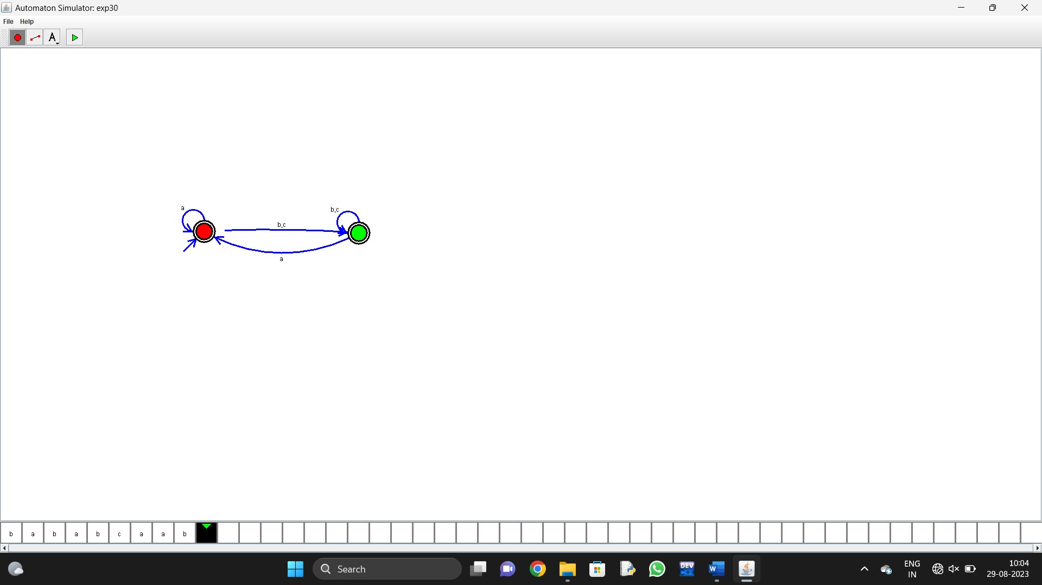

1. Design DFA using simulator to accept even number of c’s over the set {a,b,c}

Automaton Simulator, v1.0

dfa {

alphabet {abcd*}

state {

initial {yes}

final {yes}

coord {389 367}

}

state {

coord {667 362}

}

edge 0 1 {

transits {c}

offset {0.0902215331530824}

}

edge 1 0 {

transits {c}

offset {6.843027684915025}

}

edge 1 1 {

transits {ab}

offset {2.356194490192345}

}

edge 0 0 {

transits {ab}

offset {2.356194490192345}

}

}

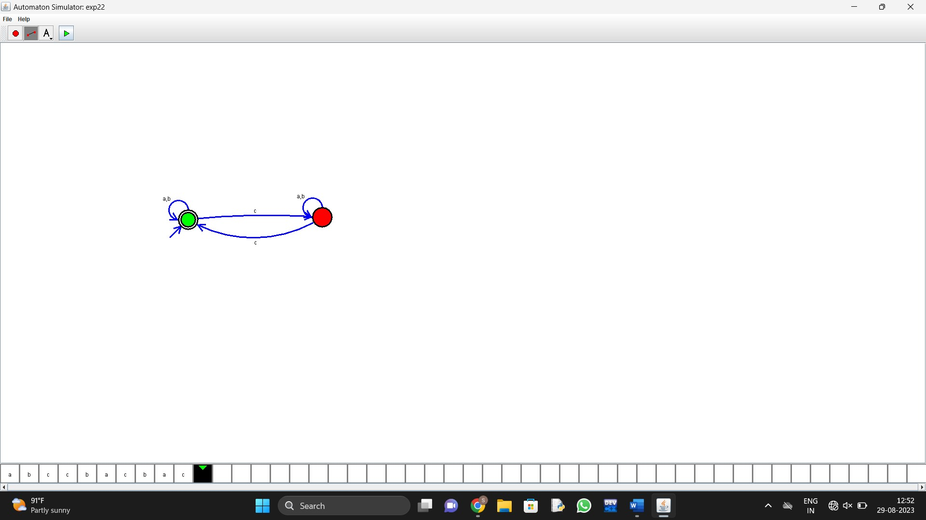

1. Design DFA using simulator to accept strings in which a’s always appear tripled over input {a,b}

Automaton Simulator, v1.0

dfa {

alphabet {abcd*}

state {

initial {yes}

final {yes}

coord {301 284}

}

state {

coord {491 292}

}

state {

coord {693 299}

}

state {

final {yes}

coord {863 301}

}

edge 0 1 {

transits {a}

offset {0.6224504734894787}

}

edge 1 2 {

transits {a}

offset {0.5235987755982988}

}

edge 2 3 {

transits {a}

offset {0.5235987755982988}

}

edge 0 0 {

transits {b}

offset {2.356194490192345}

}

edge 3 0 {

transits {b}

offset {0.5235987755982988}

}

}

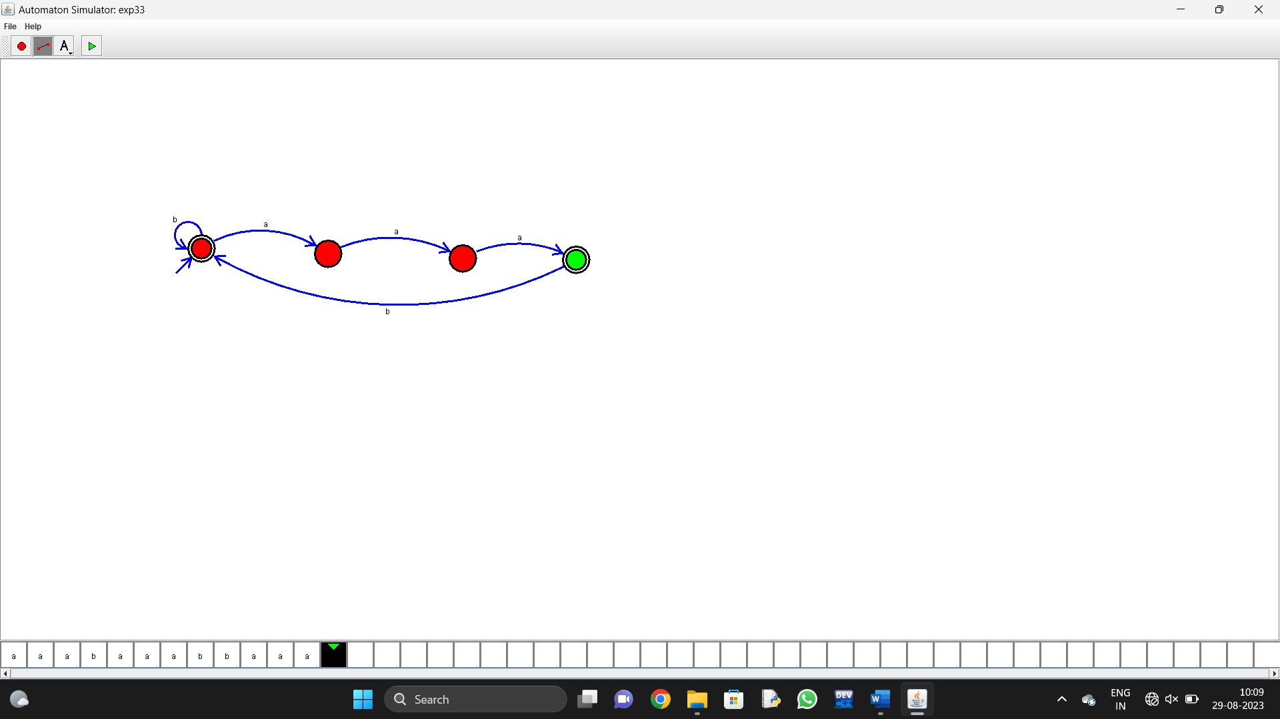

1. Design NFA using simulator to accept the string the start with a and end with b over set {a,b} and check W= abaab is accepted or not.

Automaton Simulator, v1.0

nfa {

alphabet {abcd*@}

state {

initial {yes}

final {yes}

coord {543 316}

}

edge 0 0 {

transits {ab}

offset {2.356194490192345}

}

}

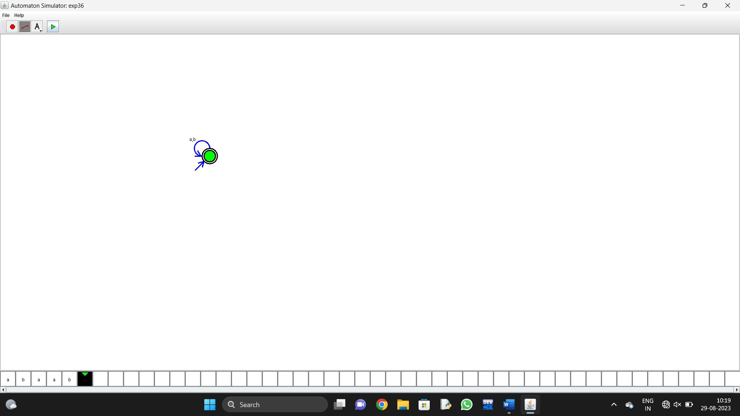

1. Design NFA using simulator to accept the string that start and end with different symbols over the input {a,b}.

Automaton Simulator, v1.0

nfa {

alphabet {abcd*@}

state {

initial {yes}

final {yes}

coord {543 316}

}

edge 0 0 {

transits {ab}

offset {2.356194490192345}

}

}



1. Design NFA using simulator to accept the input string “bbc” ,”c”,and ”bcaaa”.

Automaton Simulator, v1.0

nfa {

alphabet {abcd*@}

state {

initial {yes}

final {yes}

coord {442 293}

}

state {

final {yes}

coord {631 301}

}

edge 0 1 {

transits {c}

offset {0.5235987755982988}

}

edge 0 0 {

transits {ab}

offset {2.356194490192345}

}

edge 1 0 {

transits {ab}

offset {0.5235987755982988}

}

}

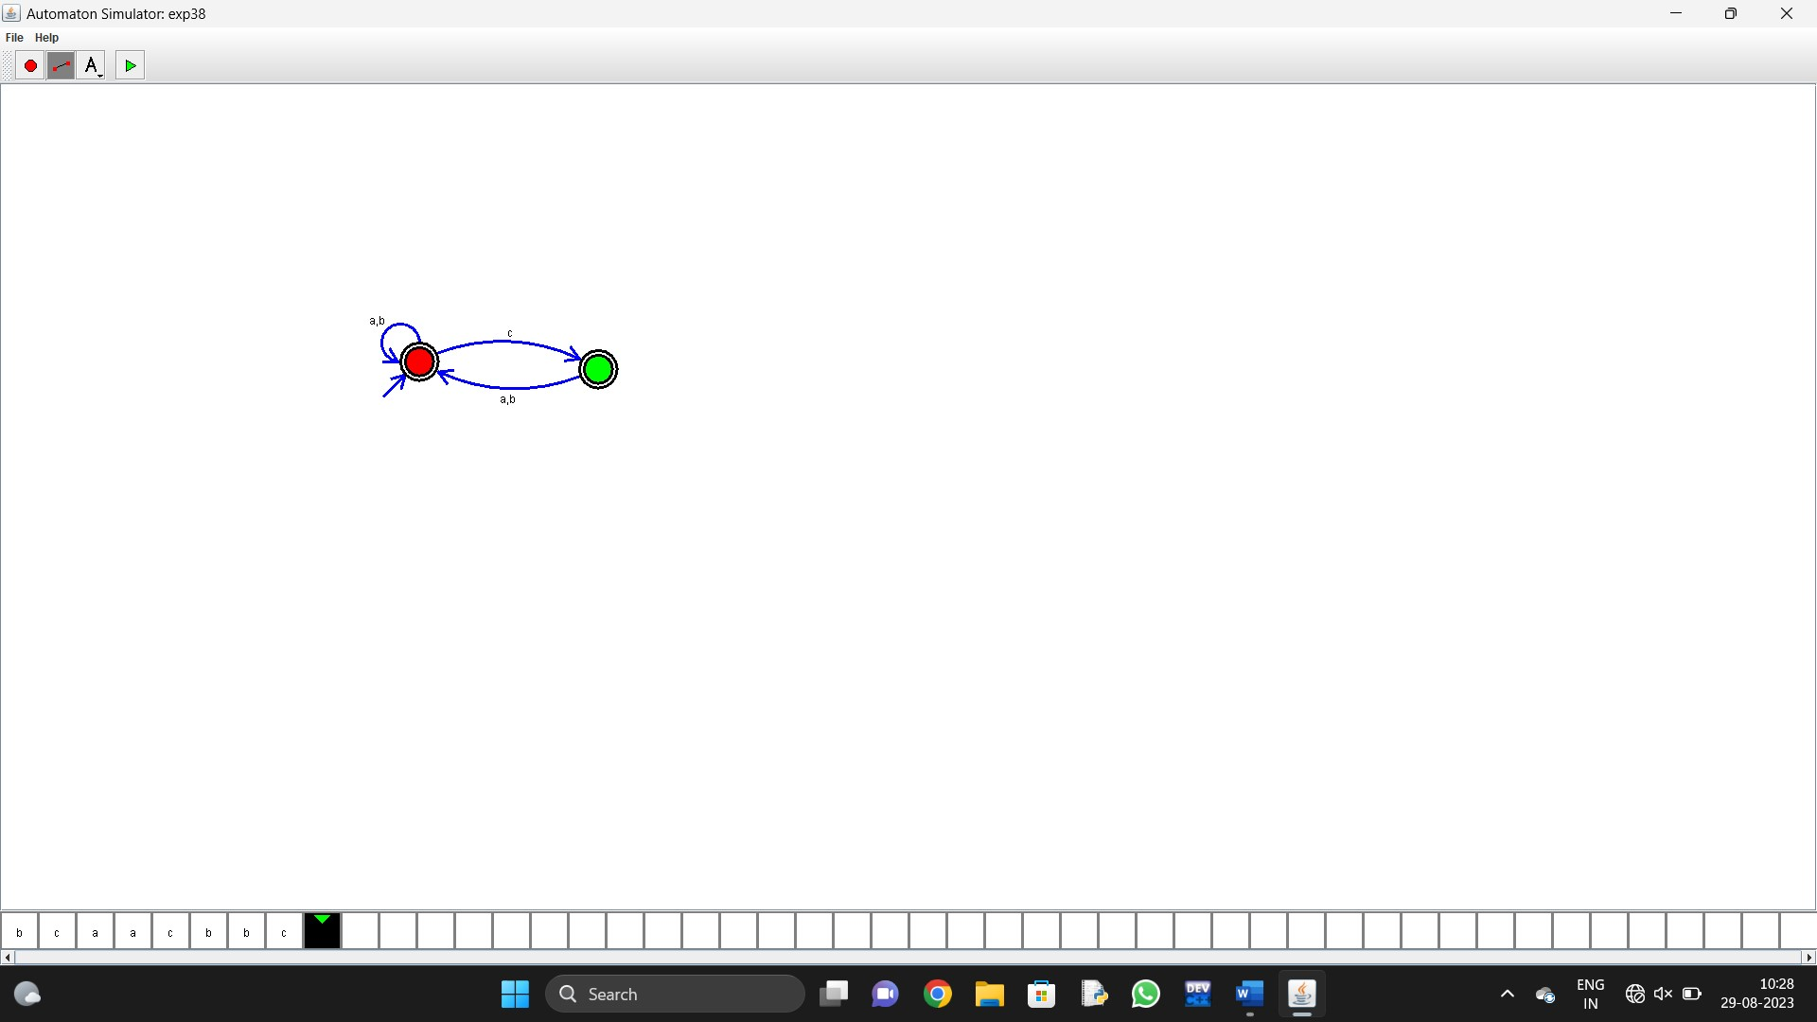

1. Design DFA using simulator to accept the string the end with abc over set {a,b,c)

W= abbaababc

Automaton Simulator, v1.0

dfa {

alphabet {abcd*}

state {

initial {yes}

coord {681 349}

}

state {

final {yes}

coord {878 348}

}

edge 0 0 {

transits {ab}

offset {2.304957322788926}

}

edge 0 1 {

transits {c}

offset {0.5235987755982988}

}

edge 1 0 {

transits {ab}

offset {0.5235987755982988}

}

}

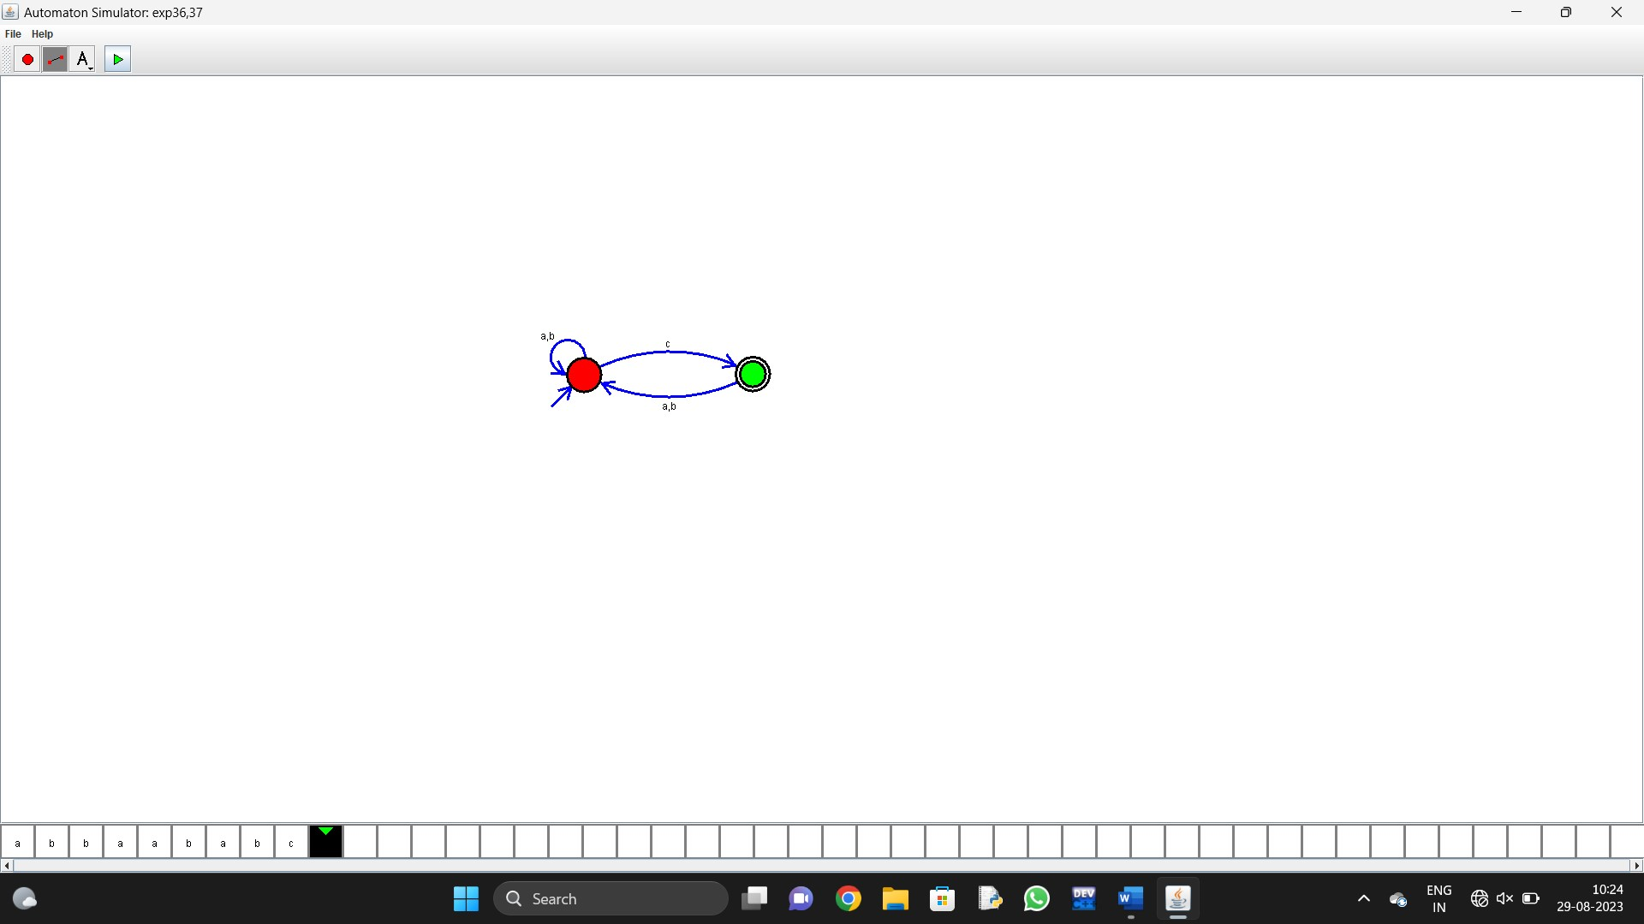

1. Design NFA to accept any number of b’s where input={a,b}.

Automaton Simulator, v1.0

nfa {

alphabet {abcd*@}

state {

initial {yes}

final {yes}

coord {543 316}

}

edge 0 0 {

transits {ab}

offset {2.356194490192345}

}

}

